

Systems Architecture

Systems Architecture for General Aviation Aircraft System
Anurag Yadav, Aryavardhan Singh, Janhavi Gaikwad
SYSEN 5400, Spring 2026

Index
Systems Architecture 1
Index 2
Table of Figures 4
1. Introduction 6
2. Stakeholder Analysis 8
2.1 Stakeholder Identification and Characterization 8
2.2 Stakeholder Value Network 10
2.3 Stakeholder Prioritization 10
2.3.1 Priority Ranking and Discussion 11
2.4 Critical Value Loops 11
3. Tradespace Exploration 12
3.1 Formulation 12
3.1.1 Architectural decisions, alternatives, and metrics 12
3.1.2 Enumeration-level constraints and the architectural decision graph 16
3.1.3 Size of the global architecture space 17
3.2 Enumeration 18
3.3 Evaluation 21
3.3.1 Decision-to-Metric Mapping Framework: 21
3.3.2 Value function Model 22
3.3.3 Evaluation Framework Summary and Modeling Rationale 26
3.3.4 Tradespace 27
3.4 Tradespace Analysis 30
3.4.1 Global Structure of the Feasible Tradespace 30
3.4.2 Pareto Structure and Near-Optimal Regions 33
3.4.3 Sensitivity and Connectivity of the Architectural Decisions 34
3.4.4 Simmon’s 4-Quadrant Interpretation of the Tradespace 35
3.4.5 Feature Mining and Architectural Design Rules 36
3.4.6 Cross-Check Against the Genetic Algorithm Results 37
3.4.7 Summary of Driving Decisions 37
3.5 Optimization and Selection 38
3.5.1. Optimization Setup (Multi-Objective Genetic Algorithm) 38
3.5.2. Pareto Front Structure and GA Convergence Behavior 39
3.5.3. Selected Pareto-Optimal Architectures 40
3.5.4. Rationale for Pareto Optimality 41
3.5.5. Model Interpretation and Limitations 41
3.5.6. Summary 42
4. Architecture Description 43
4.1 Selected Architecture Encoding and Rationale 43
4.2 System Concept and Concept of Operations 43
4.3 Functional Architecture 45
4.4 Physical Architecture 47
4.4.1 Block hierarchy 47
4.4.3 Level-2 DSM connectivity observations 50
4.5 Allocation Architecture 51
4.5.1 Level-1 function-to-subsystem allocation 51
4.5.2 Level-2 sub-function to component allocation key mappings 51
4.6 Architecture Summary 52
5. Conclusion 52
6. References 55
Appendix 56

List of Figures
Figure 2.1: Stakeholder value Network. 10
Figure 3.1:Architectural decision space for the next-generation GA aircraft 16
Figure 3.2: Reliability vs. Durability Tradespace 27
Figure 3.3: Certification Schedule vs. Reliability Tradespace 27
Figure 3.4: Durability vs.Cost Tradespace 28
Figure 3.5 : Cost vs.Reliability Tradespace 28
Figure 3.6 : Cost vs.Certification Schedule Tradespace 29
Figure 3.7 : Operating Cost vs Propulsion Reliability tradespace chart 30
Figure 3.8 : Operating Cost vs Certification Schedule tradespace chart 31
Figure 3.9 : Tradespace Scatterplots and Histograms 32
Figure 3.10 : Fuzzy Pareto frontier highlighted on the cost-reliability plot 33
Figure 3.11 : Simmon’s 4-Quadrant Decision Chart 35
Figure 4.1 : Activity Diagram - Primary Use Case 43
Figure 4.2 : State Diagram 44
Figure 4.3: Sysml Bdd & hierarchical decomposition of functions 45
Figure 4.4: Physical Architecture : Block Definition Diagram 47
Figure 4.5: Internal Block Diagram 48
Figure 4.6: Level-2 Design Structure Matrix. 49
Figure 4.7: Level-1 Allocated Architecture Activity Diagram with swimlanes. 50

List of Tables
Table 2.1: Stakeholder identification and weighted occurrence scores. 10
Table 2.2: Top three stakeholder value loops identified from network analysis. 11
Table 3.1: Architectural decision space for the next-generation GA aircraft. 16
Table 3.2: Global Architectural decision space 18
Table 3.3:Decision-to-Metric Mapping Framework 22
Table 4.1: Architecture A decision vector. 43
Table 4.2: Level-1 primary functions. 46
Table 4.3: Physical block hierarchy. 48
Table 4.4: Level-1 physical and informational interfaces. 49
Table 4.5: Level-1 physical and informational interfaces. 49
Table 4.6: Performance against system goals.. 52

1. Introduction
General aviation (GA) aircraft remain central to personal transportation, training, and light utility missions, yet much of the current fleet still reflects architectures conceived decades ago. The project addressed in this report focuses on a next-generation family of 4–8 seat GA aircraft designed around a resilience-first philosophy rather than incremental performance improvement alone. At the conceptual level, the system explores hybrid-electric propulsion, improved redundancy, advanced flight-envelope protection, and a modular platform structure intended to support multiple mission roles under a shared architecture. This work is intentionally limited to the system architecture level; detailed aerodynamics, structural sizing, and component-level design are outside the scope of the analysis.
The motivation for improving the current GA baseline is rooted in three persistent problems: accident risk, operating cost, and environmental impact. Conventional single-engine aircraft remain vulnerable to single-point propulsion failure and loss-of-control events, and the project framing explicitly identifies these failure modes as major contributors to fatal accident risk. At the same time, the sector faces increasing pressure to reduce carbon emissions and operating expenses without sacrificing the affordability that makes GA viable. The proposed system therefore seeks to improve survivability during off-nominal events, reduce lifecycle fuel burn, and preserve practical ownership economics for operators, schools, and private users.
The technical basis for the concept is a hybrid-electric GA platform that combines conventional energy conversion with electrified propulsion and modern safety logic. The project’s reference architectures include a conventional single-engine piston aircraft such as the Cessna 172, a modern composite GA aircraft such as the Cirrus SR series with ballistic recovery capability, and emerging hybrid-electric distributed-propulsion demonstrators such as NASA’s X-57 concept. These reference systems illustrate the design space from mature, certifiable baseline aircraft to more experimental distributed architectures. The intended design direction is not to pursue novelty for its own sake, but to combine the certifiability of established Part 23 aircraft with the redundancy, monitoring, and control advantages of electric and digital subsystems.
This report treats the aircraft as a socio-technical system whose success depends on more than flight performance alone. As established in the stakeholder analysis, owners, passengers, flight schools, manufacturers, insurers, regulators, MRO providers, and airport authorities all impose distinct requirements on the architecture. Owners require low operating cost and insurability; passengers require survivability and comfort; flight schools require durability and forgiving handling; regulators require compliance and failure-mode evidence; and MRO providers require maintainability and accessible parts. These stakeholder needs create a strong design pressure toward architectures that are safe, maintainable, and economically credible, not merely technically feasible.
Accordingly, the remainder of the report develops a structured tradespace model for evaluating discrete architectural alternatives across propulsion, energy storage, redundancy, avionics integration, and safety recovery. The objective is to identify which design choices most strongly shape operating cost, reliability, durability, and certification schedule, and to determine which combinations of choices form viable candidate architectures for a future GA aircraft family. In that sense, the introduction to this project is not only about a new aircraft concept; it is also about the systematic evaluation of how to make a safer, lower-emission, and more maintainable aircraft architecture credible within the constraints of modern general aviation.

2. Stakeholder Analysis
This section identifies, characterizes, and prioritizes the main stakeholders of the next-generation General Aviation (GA) aircraft system and their associated needs. The analysis employs a Weighted Stakeholder Occurrence method, which quantifies each stakeholder's importance by summing the I×B score of every value-flow edge that touches that node in the directed graph both incoming and outgoing. Concretely, for each stakeholder node the score is computed as the weighted degree: G.degree(node, weight='weight') in NetworkX library, which sums the weight attribute across all edges connected to that node regardless of direction. This means a stakeholder accumulates a score both when it sends value to another node and when it receives value, so a node with many high-intensity bidirectional flows scores higher than one with only a few weak connections. This approach captures not merely the number of connections a stakeholder holds, but the cumulative value intensity of those relationships distinguishing, for example, Aircraft Owners (who participate in high-scoring flows with the System, Insurers, Airports, and Passengers simultaneously) from Local Communities (whose single low-intensity rim connection yields the minimum score).

2.1 Stakeholder Identification and Characterization
Twelve major stakeholder groups were identified spanning operators, regulators, financiers, infrastructure providers, and the public. Table 2.1 presents each stakeholder alongside a description of their role and their primary needs with respect to the system.
Rank | Stakeholder | Description | Primary Needs | Score
1 | Aircraft Owners | Individuals or entities that purchase and hold legal title to the aircraft. They may also be pilots. They act as the financial hub connecting supply, infrastructure, and demand sides of the network. | Low direct operating costs | 62
 |  |  | High resale value
 |  |  | Insurability and affordable premiums
 |  |  | Reasonable acquisition cost
2 | Passengers / Users | Individuals traveling in the aircraft for transportation or leisure. They are the ultimate source of market demand and drive the revenue model for aircraft owners. | High safety assurance (survivability) | 36
 |  |  | Comfort and ergonomics
 |  |  | Affordability of travel
 |  |  | Speed and convenience
3 | Flight Schools | Organizations providing pilot training. They represent a primary market for 4-seat trainers and act as bulk fleet operators bridging the manufacturer and the MRO/student ecosystem. | High durability | 33
 |  |  | Low hourly operating costs
 |  |  | Forgiving flight characteristics
3 | Investors / Shareholders | Financial backers of the manufacturing partner. Their high weighted score reflects the capital-intensive nature of aerospace development. | Return on investment (ROI) | 33
 |  |  | Market share growth in the GA sector
 |  |  | Minimized development risk
4 | Aerospace Manufacturer | The industrial partner responsible for production and sales. They provide the production capabilities and supply chain that make the system physically realizable. | A certifiable design | 30
 |  |  | Manufacturability
 |  |  | Competitive advantage over existing fleets
5 | MRO Providers | Mechanics and repair shops responsible for maintaining the aircraft. Their service network availability directly enables continued operation for flight schools and owners. | Accessibility of parts | 25
 |  |  | Ease of diagnostics
 |  |  | Training on next-gen composite repair and avionics
6 | Aviation Insurance Companies | Companies insuring hulls and liability for operators. They function as a market enabler: favorable insurability ratings lower the effective cost of ownership. | Statistical proof of reduced risk | 23
 |  |  | Data on safety systems (envelope protection)
7 | Airport Authorities | Managers of regional and general aviation airports. They provide essential infrastructure and their support is a prerequisite for actual aircraft operation. | Reduced noise pollution | 17
 |  |  | Compatibility with existing fuel/energy infrastructure
8 | FAA (Regulators) | The US government body governing airworthiness standards (Part 23). A boolean gatekeeper: without typecertification, no commercial operation is possible. | Compliance with safety regulations | 15
 |  |  | Proof of reliability for novel propulsion
 |  |  | Failure mode analysis
9 | Private Pilots | Individuals licensed to operate the aircraft for personal or non-commercial travel. Critical for safety and operational feedback, though they interact with the system operationally rather than financially. | Simple and intuitive cockpit interface | 13
 |  |  | Forgiving flight characteristics
 |  |  | Enhanced safety features
10 | Government Sponsor | The government innovation body funded and backed the project to improve national transportation safety and reduce environmental impact. | Measurable reduction in aviation accident rates | 10
 |  |  | Lower carbon emissions
 |  |  | Technological prestige
11 | Local Communities | People living near general aviation airports. They provide the social license to operate. Their acceptance is largely passive but can become an active constraint if environmental concerns escalate. | Reduced noise levels | 3
 |  |  | Elimination of lead pollution (AvGas)
 |  |  | Lower carbon emissions

Table 2.1: Stakeholder identification and weighted occurrence scores.

2.2 Stakeholder Value Network
The stakeholder value network (Figure 2.1) is organized as a Hub-and-Spoke topology with Rim Connections, also referred to as a Partial Mesh. The Project/System architecture occupies the central hub position, mediating primary value exchanges with all twelve stakeholder groups via bidirectional radial flows (spokes). Additionally, five direct lateral exchanges (rim connections) exist between stakeholders: Owners ↔ Insurers, Owners ↔ Airports, Schools ↔ MROs, Manufacturer ↔ Investors, and Passengers ↔ Owners.
A key structural feature is the presence of secondary demand hubs: Private Pilots and Flight Schools together act as a customer cluster that attracts additional connections from Insurers, MROs, and Airport Authorities. This concentration of connections indicates that disruption to the operator community would propagate broadly across the network.
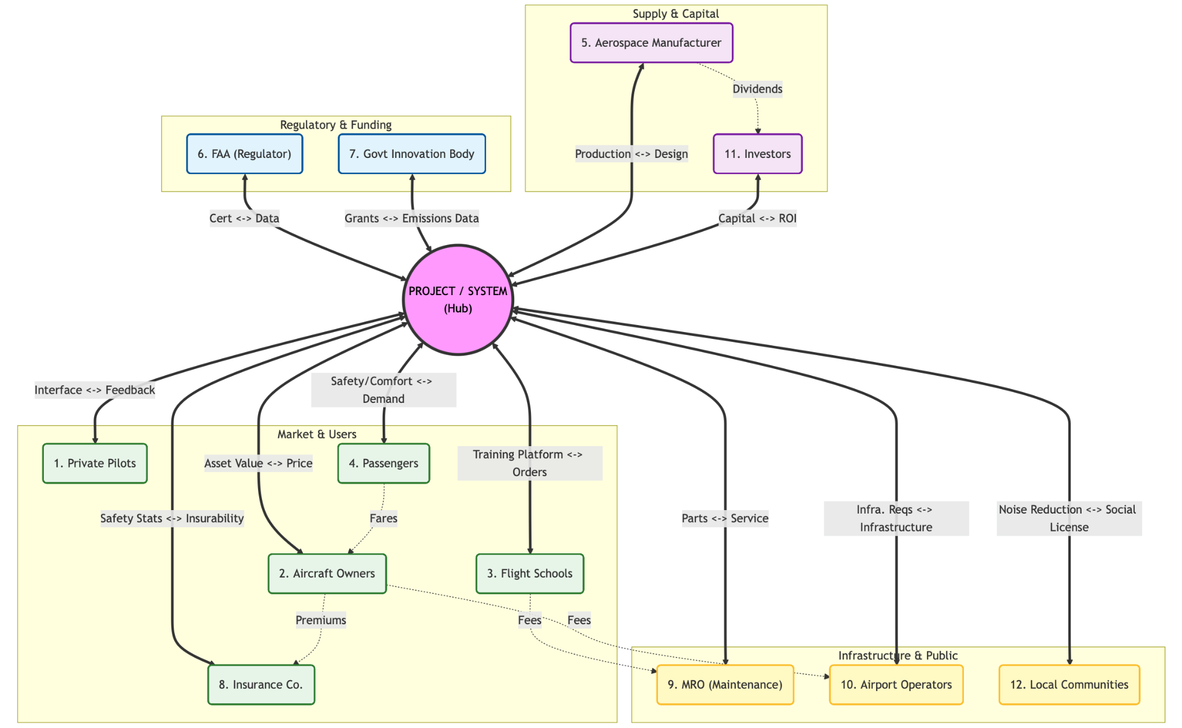

Figure 2.1: Stakeholder value Network.

2.3 Stakeholder Prioritization
Stakeholder importance was quantified using the Weighted Stakeholder Occurrence method. Each value flow in the network was assigned a semi-quantitative score (Importance × Benefit, each scored 1–3), and each stakeholder’s total score was computed as the sum of all flow scores entering and leaving that node. This method rewards stakeholders who participate in high-intensity, high-frequency value exchanges.

2.3.1 Priority Ranking and Discussion
Aircraft Owners (score: 62) rank first by a significant margin, functioning as the financial nexus of the network. They simultaneously transact with the System (purchase price, asset value), the insurance market (premiums, coverage), airport infrastructure (fees, runway access), and the passenger market (fares, transportation). If owners cannot construct a viable business case, the market for the aircraft collapses entirely.
Passengers (score: 36) rank second as the ultimate demand driver. Their public confidence and willingness to fly determine whether owners have a revenue model. Safety and comfort are therefore not merely design preferences but commercial imperatives. Flight Schools and Investors share third rank (score: 33 each): schools as high-utilization fleet operators whose bulk orders anchor early-phase revenue, and investors as providers of the capital without which development cannot proceed.
Two notable limitations of the Weighted Stakeholder Occurrence method are exposed by the results. First, Private Pilots rank ninth (score: 13) despite being the primary human operator of the system. Because pilots interact operationally rather than financially, their value flows are lower in intensity under this model, creating an Operator vs. Check-Writer bias that risks under-weighting human factors considerations. Second, the FAA ranks eighth (score: 15) despite functioning as an absolute binary gate: without type certification, commercial operation is legally prohibited. The method treats all stakeholders as additive influences, failing to capture the Boolean constraint nature of regulatory gatekeepers. These limitations suggest the prioritization results should be interpreted alongside qualitative constraint analysis rather than used in isolation.

2.4 Critical Value Loops
A computational brute-force analysis using Python and the NetworkX library was applied to identify all elementary cycles in the directed value graph. Loop scores were computed by summing the Importance × Benefit weights of all constituent edges. The three highest-scoring loops are summarized in Table 2.2.
Rank | Loop Name | Path | Score | Significance
1 | Passenger Confidence Loop | Owners → Passengers → System → Insurers → Owners | 31 | Highest-scoring loop. Links market demand (passengers), financial risk (insurers), and technical performance (safety data). Demonstrates that owner operations are gated by demonstrated safety.
2 | Capital Expansion Loop | Manufacturer → System → Investors → Manufacturer | 27 | Captures the core funding cycle. The project team converts manufacturing capability into investor ROI, enabling continued production. Without this loop, the aircraft cannot be built.
3 | Operational Sustainment Loop | Schools → System → MRO → Schools | 24 | Represents the service ecosystem lifecycle. Flight schools depend on MRO availability; MROs depend on the system providing valid technical data. A failure in this loop grounds the fleet.

Table 2.2: Top three stakeholder value loops identified from network analysis.
The dominance of complex multi-node cycles over simple bilateral trades is the most important structural finding. Every top-ranked loop involves an intermediary stakeholder that must independently receive value from the system before the primary customer relationship can be sustained. This demonstrates that the aircraft cannot succeed as a standalone product: it requires a synchronized ecosystem in which safety data flows to insurers, technical documentation flows to MROs, and financial returns flow to investors, all in parallel with delivering the core product to owners and schools.

3. Tradespace Exploration

3.1 Formulation
This section describes the enumerable architecture model for the next-generation hybrid-electric General Aviation (GA) aircraft. The model comprises eight architectural decisions (D1–D8), each with a finite set of discrete alternatives. These decisions collectively define the design tradespace across propulsion, energy storage, avionics, and safety subsystems. The model draws directly from the full-factorial enumeration work completed in detail in previous exercises.

3.1.1 Architectural decisions, alternatives, and metrics
Table 3.1 presents all eight decisions with their alternatives, canonical decision type and justification, and the performance metrics each decision drives. Decision types follow the standard taxonomy: Standard Form (SF) for mutually exclusive pick-one selections, Downselecting (DS) for subset selection from a constrained candidate set, and Partitioning (PA) for exhaustive assignment of elements into groups.
Decision ID | Decision Name | Description & connection to metrics | Alternative | Canonical Type & Justification
D1 | Propulsion topology | How the thermal engine and electric motors are mechanically and electrically coupled to produce shaft thrust. This single architectural choice defines the entire powertrain layout. | A. Series hybrid- ICE charges battery only, electric motor(s) drive propeller exclusively; decouples thermal and propulsive systems | This is Standard form (SF) decision type with 3 \alternatives, because exactly one power-train topology is selected, alternatives are architecturally mutually exclusive. Each implies a completely different mechanical and electrical layout (function-to-form mapping, Task is Specializing or Characterizing). SF is the correct pattern for this: one choice, finite discrete set, space size = 3.
 |  |  | B.Parallel hybrid- ICE and electric motor(s) both mechanically drive the propeller shaft simultaneously; highest efficiency at cruise
 |  | Metrics related to goals-  G9 fuel savings ≥20%  G10 op. cost ≤$250/hr  G1 reliability ≥99%  G6 redundancy | C.Turboelectric- gas turbine drives a generator, electrical power distributed to wing-mounted motor-propulsors; best for distributed propulsion
D2 | Battery pack chemistry | Electrochemical cell type adopted across the main energy storage pack. Determines gravimetric energy density, thermal risk, cycle life, and LRU replacement cost across the aircraft's operational lifetime. | A. Li-Ion NMC (Nickel Manganese Cobalt) ~250 Wh/kg; high energy density; elevated thermal risk; mature aviation supply chain | This is a Standard Form decision (SF) with 3 alternatives. One chemistry adopted across the entire pack, no valid mixed-chemistry architecture exists at system level. Discrete, mutually exclusive options (Characterizing Form). Independent of all other decisions at the enumeration level: D2 feeds directly to the completed architecture without constraining any downstream decision.
 |  |  | B. Li-Ion LFP (Lithium Iron Phosphate)~180 Wh/kg; superior thermal stability and cycle life; preferred for safety-critical aviation
 |  | Metrics related to goals-  G9 energy density to range  G10 unit replacement cost  G4 thermal safety  G14 fault tolerance | C. Solid-state ~400 Wh/kg projected; eliminates liquid electrolyte; TRL( technology readiness level) 4–5, near-term adoption risk
D3 | Number of electric motors | Count of independent electric propulsor units installed on the airframe. Sets propulsion redundancy level and its critical to determine the size of the motor-to-position | A. 1 motor- centralised; minimum weight; no propulsion redundancy; single-point failure risk | This is a Standard Form (SF) type decision. A single integer count chosen from a finite discrete set (Specializing Form). D3 is not independent of D4: the motor count directly sets the number of rows in the AS assignment matrix for D4, making D3 to D4 a mandatory ADG edge. This is an enumeration-level dependency.
 |  |  | B. 2 motors- twin configuration; standard redundancy for GA category aircraft; enables differential thrust
 |  | Metrics related to goals-  G1 reliability  G6 propulsion redundancy  G9 distributed propulsion efficiency  G10 weight & maintenance cost | C. 4 motors- quad-distributed propulsion; highest fault tolerance; differential yaw/roll control without control surfaces
D4 | Motor-to-airframe position assignment | Ordered mapping of each electric motor unit to a structural mounting position on the airframe. Both the candidate position set (constrained by D1 topology) and the matrix size (set by D3 motor count) are determined by upstream decisions. | A. Possible Candidate positions of motors (up to 6): Wing-root-Left, Wing-root-Right, Wing-tip-Left, Wing-tip-Right, Nose, Tail | This is an Downselecting type (DS) decision, which depends on D1, D3. This is selecting the available option for the position of engines from the set of available option (n=6). It is constraint by number of motors we are going to choose in D1 and Type of motors we are going to choose in D4
 |  |  | B. D1 topology removes 1–2 positions (e.g. Series: Nose occupied by ICE)
 |  | Metrics related to goals-  G3 flight control authority  G13 lateral/directional stability  G17 handling qualities  G18 fault tolerance | C. Each motor maps to exactly one position; space = P(valid_n, D3_count) ordered permutations
D5 | Flight control computer (FCC) redundancy level | Redundancy architecture of the flight control computers, how many independent FCC units are installed and whether voting logic (2-of-3) is implemented to mask individual failures automatically. | A. Simplex- 1 FCC; lowest cost and weight; limits certification to Normal category; single-point failure | This is the standard Form (SF) decision type. If one redundancy level is selected, architectures are mutually exclusive(Characterizing Form). Choosing Triple-redundant imposes an enumeration-level constraint on D7: the three FCC units must each reside in a separate LRU package to preserve physical fault isolation, creating the ADG edge D5 → D7.
 |  |  | B. Dual-redundant- 2 FCCs with cross-monitoring and failover; standard for Part 23 Enhanced category
 |  | Metrics related to goals-  G2 FAA Part 23 certification  G4 high durability  G14 fault tolerance  G18 critical system redundancy | C. Triple-redundant- 3 FCCs with 2-of-3 majority voting; required for Design Assurance Level (DAL)-A flight-critical systems
D6 | Avionics integration | Whether avionics subsystems use dedicated hardware per function (federated) or a shared certifiable computing platform Integrated Modular Avionics (IMA). Determines which sub-function co-packaging rules are physically feasible in D7. | A. Federated-each avionics function has its own dedicated LRU box; high fault isolation; higher weight and part count | Standard Form (SF) decision, with 2 alternatives. Binary, mutually exclusive pick-one (Specializing Form).
 |  | Metrics related to goals-  G2 FAA certification path  G7 accommodate new technologies  G17 situational awareness  G20 Ease in operations | B. Integrated Modular Avionics (IMA)- shared certifiable computing platform, lower SWaP (Size, Weight & Power), incremental certification harder
D7 | Subsystem LRU decomposition | How the 6 Level-1 functions from functional architecture (F1–F6) are grouped into physical Line-Replaceable Unit (LRU) packages. Determines maintenance access granularity and replacement cost over the aircraft lifecycle. | A. Elements: all 6 Level-1 sub-functions F1–F6 from functional BDD | Partitioning (PA) decision type. Sub-functions are partitioned into mutually exclusive, collectively exhaustive LRU packages- this is the Partitioning (PA) pattern by definition (System Decomposition task). Every sub-function belongs to exactly one LRU, all 6 must be assigned. Space size depends on D5.
B. Groups: only k=2 or 3 LRU packages
Minimum possible LRU packages maintains redundancy without compromising cost
 |  | Metrics related to goals-  G7 accommodate new technologies  G8 health monitoring  G10 LRU replacement cost  G20 modularity | C. If D5=Triple: FCC units must be in separate packages (k=3 groups required)
D8 | Ballistic whole-aircraft parachute (Cirrus Airframe Parachute System (CAPS)) | Whether a ballistic whole-aircraft parachute recovery system is installed as a last-resort mechanism for loss-of-control events beyond FCC recovery capability. Direct tradeoff between safety and weight/cost. | A. CAPS installed, adds ~25–30 kg, substantially improves survivability in LOC events; earns FAA safety credit toward certification | Standard Form (SF) decision type with binary go/no-go selection (Specializing Form) with direct, measurable effects on safety and cost metrics. Fully independent of all other decisions at the enumeration level, no upstream decision changes this decision's option set. D8 feeds directly to the completed architecture without constraining any downstream decision.
 |  |  | B. No CAPS, lower weight and acquisition cost; relies entirely on avionics, structural, and flight control safety systems
Metrics related to goals-
G2 FAA safety requirements
G4 durability & passenger safety
G10 +25–30 kg weight penalty
G14 maneuverability & high safety

Table 3.1: Architectural decision space for the next-generation GA aircraft.

3.1.2 Enumeration-level constraints and the architectural decision graph
Not all decisions are independent. Four enumeration-level constraints alter the number or set of valid alternatives for a downstream decision and are captured in the Architectural Decision Graph (ADG) shown in Figure 1. Decisions D2 and D8 are independent root nodes, their option sets are unaffected by any upstream choice.
First, propulsion topology (D1) constrains the valid motor mounting positions in D4. The Series and Parallel topologies block the Nose position (occupied by the ICE or gearbox shaft), leaving n=5 valid positions. The Turboelectric topology additionally blocks the Tail position (turbine exhaust clearance), leaving n=4. This is the ADG edge D1 → D4.
Second, motor count (D3) sets the size k of the assignment matrix for D4. A different motor count produces a fundamentally different combinatorial space, not merely fewer choices within the same space. This is the ADG edge D3 → D4, making D4 jointly constrained by both D1 and D3.
Third, triple-redundant FCC selection in D5 forces the D7 LRU partition to contain at least three groups, with FCC-A, FCC-B, and FCC-C each in a physically distinct package. Any partition placing two FCC units in the same LRU is infeasible and eliminated from enumeration. This is the ADG edge D5 → D7.
Fourth, avionics integration architecture (D6) determines which sub-function co-packaging rules are physically feasible in D7, providing additional feasibility filtering at the enumeration level the ADG edge D6 → D7.
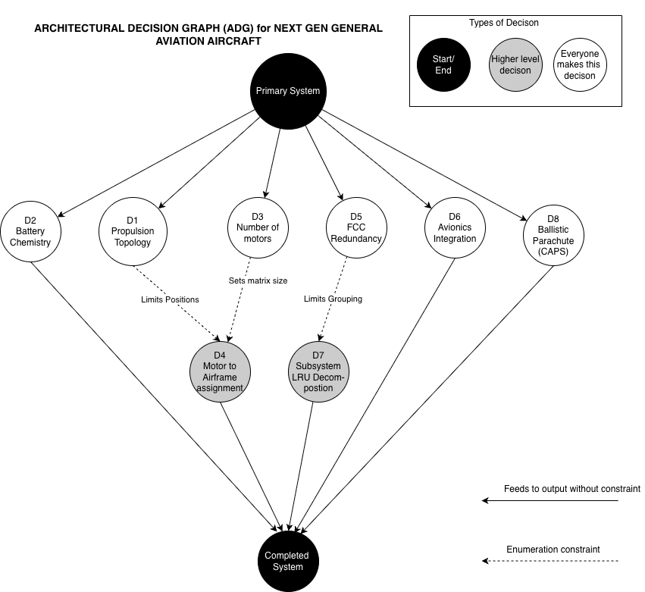

Figure 3.1:Architectural decision space for the next-generation GA aircraft

Solid edges = feeds directly to completed system without constraint; dashed edges = enumeration-level constraint that changes the downstream option set.

3.1.3 Size of the global architecture space
Table 3.2 summarizes the size contribution of each decision and the combined constrained total. For the jointly constrained decisions (D1×D3×D4 and D5×D7), the space is computed by summing across all valid upstream combinations rather than multiplying independently.
Decision | Type | Alts | Alternatives / constraint logic | Enumeration size
D1 | Standard Form | 3 | {Series, Parallel, Turboelectric} | N = 3 × 1 = 3
D2 | Standard Form | 3 | {Li-Ion NMC, Li-Ion LFP, Solid-state} | N = 3 × 1 = 3
D3 | Standard Form | 3 | {1 motor, 2 motors, 4 motors} | N = 3 × 1 = 3
D4 | Downselecting (DS) | Varies | C(n, k): n=5 (Series/Parallel), n=4 (Turboelectric); k=D3 value | N(D1×D3×D4) = 20+20+11 = 51
D5 | Standard Form | 3 | {Simplex, Dual-redundant, Triple-redundant} | N = 3 × 1 = 3
D6 | Standard Form | 2 | {Federated, IMA} | N = 2 × 1 = 2
D7 | Partitioning (PA) | Varies | S(6,2) + S(6,3) if D5=Simplex; S(6,3) only if D5=Dual/Triple | N(D5×D7) = 121+90+90 = 301
D8 | Standard Form | 2 | {CAPS installed, No CAPS} | N = 2 × 1 = 2

Table 3.2: Global Architectural decision space

The total constrained architecture space is computed as:
Nᵀᵒᵗᵃˡ = N(D1×D3×D4) × Nᴰ² × N(D5×D7) × Nᴰ⁶ × Nᴰ⁸
= 51 × 3 × 301 × 2 × 2 = 184,212 architectures
This count represents the feasible architecture space after applying all four enumeration-level constraints. The unconstrained space (treating all decisions as independent) would be substantially larger; the ADG-driven constraints reduce it to 184,212 distinct, physically realizable architectures that can be evaluated against the system performance metrics.

3.2 Enumeration
The aircraft architecture space is generated using a structured enumeration framework combining full factorial enumeration within given constraints, implemented in R using archr package. The objective is to construct complete , feasible trade space that captures all valid system architecture while explicitly respecting physical integration constraints.
Enumeration Algorithm:
The enumeration process consist of two main stages
- Enumeration:
The architecture tradespace is first created with naïve full factorial over all decisions. In the given architecture space the decisions were enumerated at following order:
- Independent full factorial decisions:
Standard Form (SF) decisions are enumerated using function enumerate_sf():
- D1 (Propulsion topology): 3 alternatives
- D2 (Battery chemistry): 3 alternatives
- D3 (Motor count): 3 alternatives
- D5 (FCC redundancy): 3 alternatives
- D6 (Avionics integration): 2 alternatives
- D8 (CAPS): 2 alternatives
This forms the initial Cartesian product space:
$A_{0}=D_{1}×D_{2}×D_{3}×D_{5}×D_{6}×D_{8}=324$
This initial space represents the independent decision backbone of the architecture and forms the basis for full factorial expansion. At this stage, all combinations are considered equally and no feasibility constraints are imposed, ensuring complete coverage of the independent design dimensions.
- Down select decision enumeration:
D4 represents a down-select combinatorial structure, where 6 candidate motor installation positions are encoded as a binary selection vector.
Each architecture is represented as a 6-dimensional binary string:
- Wing root (L/R)
- Wing tip (L/R)
- Nose
- Tail
This produces a raw space of:
$2^{6}=64 possible configurations$
However, this space is not fully independent and is later reduced through structural and symmetry constraints, as well as coupling with motor count (D3). Thus, D4 acts as a constrained combinatorial expansion rather than a pure factorial decision.
- Partition decision enumeration :
D7 represents the most structurally complex decision, formulated as a set partitioning problem over 6 functional aircraft subsystems into Line Replaceable Unit (LRU) groupings.
Two partition regimes were enumerated:
- k = 2 partitions
- k = 3 partitions
The enumeration was performed using:
- enumerate_partition(n = 6, k = {2,3})
- minimum group size constraints: each group ≥ 1 subsystem
- maximum group size constraints: bounded feasibility (≤ 4–5 elements per group)
This produces a Bell-number–type partition space, heavily pruned via symmetry removal filters:
- removal of label permutations (e.g., d7_1 == 0)
- elimination of duplicate group assignments
- structural pruning for canonical representation
D7 is therefore a constrained partition lattice, not a simple combinatorial product space.
- Constraint Based filtering:
Once all decision space were generated the full architecture set was constructed using a sequential constraint as follows:
- Propulsion contraints (D1 → D4, D3 → D4)
These constraints enforce physical feasibility:
- Propulsion topology determines unavailable installation locations
- Motor count (D3) must match number of selected positions in D4
This ensures consistent propulsion integration and physically valid motor-airframe coupling

- FCC constraints (D5 → D7)
FCC redundancy level (D5) directly constrains partition feasibility:
- Higher redundancy levels require stricter separation of FCC units across LRUs
- Certain partition sizes (k=2) are infeasible under Dual and Triple redundancy cases
This introduces hierarchical dependency between system redundancy and maintainability architecture.
After full enumeration and constraint propagation the total architecture was found 184,212. The final space represents a fully feasible tradespace suitable for downstream operation like evaluation.
From a design space perspective, the total architectural space size prior to constraint filtering is significantly larger (on the order of millions when combining D4 and D7 expansions), but constraint-based pruning reduces it to 184,212 feasible architectures. This highlights the importance of embedding domain knowledge early in the enumeration process.
No sampling strategy was used in this work, as a full enumeration approach was computationally tractable. Therefore, the sample size is equal to the total feasible architecture count (184,212), ensuring complete representativeness of the design space. This guarantees that all feasible architectures are evaluated in later stages, enabling robust identification of optimal and Pareto-efficient solutions without risk of missing critical regions of the tradespace.

3.3 Evaluation
The evaluation stage of the system architecture framework translates each enumerated design configuration into a set of quantitative, system-level performance metrics. This step forms the critical bridge between architectural design space generation and decision-making under multi-dimensional trade-offs. Each candidate architecture—defined by a unique combination of decisions $D_{1}$through $D_{8}$—is evaluated using a structured set of value functions.
These value functions map discrete architectural choices into four key performance indicators:
- Operating Cost ($/hr)
- Certification Schedule (years)
- Propulsion System Reliability (probability)
- System Durability (years)
The evaluation model is intentionally deterministic to support tractable tradespace exploration. Each metric is constructed using physically motivated aggregation rules, including additive, series, parallel, min–max, and hybrid formulations, depending on subsystem interactions.

The values presented in Table 3.3.1 are derived from a combination of:
- Engineering design heuristics from aerospace subsystem modeling
- Simplified reliability and cost scaling laws
- Assumed certification and operational benchmarks
- Structural decomposition of system-level architectures
No stochastic uncertainty modeling is included at this stage to maintain tractability in early tradespace exploration.

3.3.1 Decision-to-Metric Mapping Framework:
Each decision variable $D_{i}$represents a design choice within the system architecture. The evaluation framework assigns numerical performance attributes to each discrete option.
The full decision matrix is summarized below:
Decision ID | Decision | Type | Alternatives (Numbered) | Operating Cost ($/hr) | Propulsion Reliability (%) | System Durability (yrs) | Certification Schedule (yrs)
D1 | Propulsion Topology | Standard Form | 0: Series Hybrid | 180 | 99.6 | 9.0 | 2.0
 |  |  | 1: Parallel Hybrid | 240 | 99.3 | 8.0 | 3.0
 |  |  | 2: Turboelectric | 420 | 97.8 | 7.0 | 6.0
D2 | Battery Pack Chemistry | Standard Form | 0: Li-Ion NMC | 180 | 99.5 | 7.5 | 1.5
 |  |  | 1: Li-Ion LFP | 170 | 99.7 | 8.5 | 1.5
 |  |  | 2: Solid-State | 360 | 99.9 | 9.0 | 5.0
D3 | Number of Electric Motors | Standard Form | 0: 1 Motor | 150 | 98.8 | 8.0 | 1.5
 |  |  | 1: 2 Motors | 165 | 99.5 | 9.0 | 2.5
 |  |  | 2: 4 Motors | 200 | 99.3 | 8.5 | 4.0
D4 | Motor-to-Airframe Position | Downselecting | 0: Wing-root & Wing-tip | 160 | 99.1 | 8.5 | 2.0
 |  |  | 1: Nose & Tail | 185 | 99.4 | 9.5 | 2.5
D5 | FCC Redundancy Level | Standard Form | 0: Simplex | 140 | 98.5 | 7.0 | 1.5
 |  |  | 1: Dual-Redundant | 175 | 99.5 | 8.5 | 3.0
 |  |  | 2: Triple-Redundant | 230 | 99.95 | 10.0 | 4.5
D6 | Avionics Integration | Standard Form | 0: Federated | 160 | 99.2 | 8.0 | 2.0
 |  |  | 1: IMA | 210 | 99.1 | 9.0 | 3.5
D7 | Subsystem LRU Decomposition | Partitioning | 0: 2 LRU packages | 155 | 99.1 | 8.0 | 2.0
 |  |  | 1: 3 LRU packages | 170 | 99.2 | 8.5 | 3.0
D8 | Ballistic Parachute (CAPS) | Binary | 0: Installed | 195 | 99.8 | 9.0 | 3.5
 |  |  | 1: Not Installed | 160 | 98.9 | 8.0 | 2.0

Table 3.3:Decision-to-Metric Mapping Framework

3.3.2 Value function Model
Each metric is modeled as a deterministic function of architectural decisions, using a combination of additive, series, and parallel system representations, depending on the underlying physical and operational relationships as follows:
Operating Cost Model:
Operating cost is modeled as a fully additive function under a first-order approximation, assuming that subsystem-level costs are separable and independent. This formulation is commonly used in early-stage system architecture studies where interaction effects between subsystems are either second-order or not sufficiently characterized.
$C=C(D_{1})+C(D_{2})+C(D_{3})+C(D_{4})+C(D_{5})+C(D_{6})+C(D_{7})+C(D_{8})$
While real aerospace cost structures exhibit nonlinear interactions (e.g., integration coupling and certification-driven cost escalation), a linear additive formulation is adopted here to preserve interpretability and enable tractable tradespace enumeration.
Here,
- $C\left(D_{1}\right), C\left(D_{2}\right),C\left(D_{3}\right),C\left(D_{5}\right),C\left(D_{6}\right),C\left(D_{8}\right) :$
Directly mapped from the subsystem cost table, which embeds relative scaling effects of complexity, redundancy, and integration overhead across different architectural choices
- $C\left(D_{4}\right)$ :
Wing mounted motors and the nose/tail mounted motors have different costs. Hence total cost is computed as : number of position(wing/nose/tail)* cost for that position
- $C\left(D_{7}\right)$ :
For this partitioning decision , it is simplified to binary decision where we have different cost based on the number of partitions.
In general,
Evaluation is simplified by making costs linearly additive across subsystem. No interaction effect or NPV is modelled in this cost modelling.
The cost model does not include non-recurring engineering (NRE) costs, learning-curve effects, or time-discounted financial impacts. Additionally, economies of scale, procurement variability, and supplier-dependent pricing effects are neglected. The model therefore represents a relative cost comparison framework rather than an absolute life-cycle cost prediction tool.
Certification Schedule Model:
The certification schedule is modeled using a hybrid series–parallel critical path formulation to capture dependencies between regulatory certification activities and parallelizable subsystem certification processes. This approach approximates certification as a structured project scheduling problem rather than a stochastic workflows
$S=max⁡(S_{seq}, S_{par})$
Where,
$S_{seq}$: Represents certification activities that must occur in a fixed regulatory order due to system-level integration dependencies. In this model, propulsion, control systems, and avionics certification form a strict dependency chain
Propulsion → Control systems → Avionics
$S_{seq}=S(D_{1})+S(D_{5})+S(D_{6})$
$S_{par}$: Represents certification activities that can proceed concurrently once system-level interfaces are defined. These activities are assumed to be independent certification tracks governed by different regulatory or testing pathways.
$S_{par}=max⁡(S\left(D_{2}\right),S\left(D_{3}\right),S\left(D_{4}\right),S\left(D_{7}\right),S\left(D_{8}\right))$
Here,
- $S\left(D_{1}\right), S\left(D_{2}\right),S\left(D_{3}\right),S\left(D_{5}\right),S\left(D_{6}\right),S\left(D_{8}\right) :$
Directly obtained from cost table
- $S\left(D_{4}\right)$ :
For this assigning decision certification time is maximum of the all selected motor positions.
- $S\left(D_{7}\right)$ :
For this partition decision , the certification time is based on number of partitions chosen. Higher number of partition accounts for higher time.
In general,
The certification model is based on several simplifying assumptions. First, certification activities are assumed to be perfectly decoupled across parallel streams, with no resource contention or regulatory coupling. Second, no iteration loops, re-certification cycles, or design rework are included. Third, certification durations are assumed deterministic and invariant with respect to project execution strategy. Finally, learning effects or regulatory adaptation over time are not modeled..

Propulsion Reliability Model:
Propulsion system reliability is modeled using a series–parallel Reliability formulation to capture failure propagation pathways and redundancy effects within the architectural space. The formulation maps subsystem-level reliability into system-level reliability using structural logic rather than time-dependent stochastic degradation..
$R=R_{series}×R_{parallel}$
Where,
$R_{series}:$ Represent components for the series subsystem. The failure in these components cause failure in overall system. Propulsion topology, motor count and motor placement are critical decisions to reliability
$R_{series}=R\left(D_{1}\right)*R\left(D_{3}\right)*R\left(D_{4}\right)$
$R_{parallel}:$Represent parallel subsystems. The failure in either of these component doesn’t cause failure in overall system. Usually represent redundancy in system
$R_{parallel}=1-(1-R\left(D_{5}\right))*(1-R\left(D_{6}\right))*(1-R\left(D_{7}\right))$
This decomposition reflect two fundamental physical behaviour. Series structures are critical since failure propagates directly. While parallel structure incorporate redundancy hence failure can be tolerated.
The above is consistent with the aerospace system where propulsion topology, motor count, and motor placement form a failure-sensitive chain, while motor placement itself contains internal redundancy through spatial distribution across wing and nose/tail configurations.
Here,
- $R\left(D_{1}\right), R\left(D_{2}\right),R\left(D_{3}\right),R\left(D_{5}\right),R\left(D_{6}\right),R\left(D_{8}\right) :$
Obtained from the subsystem reliability database defined in Table 3.3.1, which encodes estimated failure probabilities based on historical aerospace subsystem performance and engineering heuristics.
- $R\left(D_{4}\right)$ :
Motor placement is modeled as a spatial redundancy system. Wing-mounted and nose/tail-mounted motors are treated as partially independent reliability contributors due to physical separation and failure isolation effects. The effective reliability is computed using a parallel redundancy formulation.
$R_{D4}=1-(1-R_{wing})(1-R_{nose/tail})$
- $R\left(D_{7}\right)$ :
For this partition decision , the certification time is based on number of partitions chosen. Higher number of partition accounts for higher time.
In general,
We have assumed that all subsystem failures are independent and there is no time dependent degradation to simplify the enumeration.
The reliability model is based on several simplifying assumptions. First, all subsystem failures are assumed to be statistically independent. Second, time-dependent degradation mechanisms such as fatigue, wear-out, and environmental aging are not modeled. Third, redundancy is assumed to provide instantaneous failover without transition delays. Finally, all reliability values are treated as static probabilities at the system design stage.
System Durability Model :
Durability is modeled using a min–max formulation, capturing the interaction between weak link failure mechanism (i.e, series behaviour) and redundancy driven life extension (i.e, parallel behaviour).
The effective system lifetime is governed by the most limiting structural pathway, whether it arises from serial dependencies or insufficient redundancy.
$L=min⁡(L_{series},L_{parallel})$
Where,
$L_{series}$ : Represent the weakest link failure model where system reliability is constrained by the least durable critical system.The system cannot outlive its weakest component
$L_{series}=min⁡({L(D}_{1}),{L(D}_{2}),{L(D}_{3}),{L(D}_{4}))$
$L_{parallel} :$ Represent life extension through architectural redundancy and subsystem diversity. The system durability here can be increased by either increasing FCC redundancy, or by changing avionics integration strategy or by changing LRU partitioning structure.
$L_{parallel}=max⁡({L(D}_{5}),{L(D}_{6}),{L(D}_{7}))$
The above is consistent with aerospace system where redundant control system improves operational lifetime, modular avionics reduce the replacement cycle and partitioned LRU introduces redundancy. So unlike series subsystem they do not collectiovely constraint life instead they provide alternative pathways for increasing durability.
Here,
- $L\left(D_{1}\right), L\left(D_{2}\right),L\left(D_{3}\right),L\left(D_{5}\right),L\left(D_{6}\right),L\left(D_{8}\right) :$
Directly obtained from cost table
- $L\left(D_{4}\right)$ :
For this assigning decision durability is maximum of the all selected motor positions due to redundancy effect.
- $L\left(D_{7}\right)$ :
For this partition decision , durability is based on number of partitions chosen. Higher number of partition accounts for higher durability.
In general,
Durability is treated as static lifetimes. Parallel subsystem extend system life through redundancy. Although this durability modeling doesn’t include maintenance or repair modeling to maintain simplicity.
The evaluation model is built on several simplifying assumptions to ensure tractability during early-stage tradespace exploration. First, subsystem contributions to operating cost, reliability, and durability are assumed to be independent unless explicitly modeled through series–parallel structures. Second, all performance metrics are treated as time-invariant and static, with no degradation or maintenance effects included. Third, interactions such as cost–reliability coupling and cross-subsystem physical dependencies (e.g., thermal or electrical coupling) are neglected. Finally, the model is fully deterministic, and uncertainty in subsystem performance is not propagated at this stage.

3.3.3 Evaluation Framework Summary and Modeling Rationale
The evaluation framework provides a structured method to convert each enumerated aircraft architecture into quantitative system-level performance measures, enabling consistent comparison across the entire tradespace. Each architecture, defined by a unique combination of decisions $D_{1}$–$D_{8}$, is mapped into four key metrics: operating cost, certification schedule, propulsion system reliability, and system durability. The formulation is intentionally deterministic to maintain tractability during early-stage tradespace exploration while preserving key physical relationships between subsystems.
The choice of modeling structures is driven by the underlying engineering interpretation of each metric. Operating cost is treated as a fully additive function because each subsystem contributes independently to lifecycle cost, and first-order estimation is sufficient at this stage without introducing interaction or financial discounting effects. This distinction between additive and non-additive formulations reflects fundamental system engineering behavior. Additive models are appropriate where subsystem contributions are independent and linearly separable, while non-additive formulations are required when system behavior is governed by interaction effects such as failure propagation, redundancy, or critical path dependencies. Certification schedule is modeled using a hybrid series–parallel structure because certification activities follow a logical dependency chain where propulsion, control, and avionics systems must be certified sequentially, while several subsystem-level certifications can proceed in parallel. This justifies the use of a critical path formulation, where total schedule is governed by the longest parallel activity combined with sequential dependencies.
Propulsion reliability is represented using a series–parallel reliability block diagram because certain subsystems such as propulsion topology, motor count, and motor placement form a tightly coupled failure chain, where failure in any element directly impacts system-level success. In contrast, redundancy-related decisions such as FCC architecture, avionics integration, and LRU partitioning introduce parallel reliability pathways that improve system robustness, justifying their treatment as parallel components in the reliability model. System durability is modeled using a min–max formulation to capture the weakest-link behavior of structural and propulsion-critical components while also accounting for redundancy-driven life extension in control, avionics, and modular subsystem design. This reflects the fact that system lifetime is constrained both by the most limiting component and by architectural redundancy that can extend operational life.
Overall, the evaluation framework is designed to preserve interpretability while reflecting key system engineering principles such as additivity, critical path scheduling, reliability propagation, and redundancy effects. It provides a consistent and computationally efficient basis for comparing architectures and supports downstream tradespace visualization and multi-objective decision-making.

3.3.4 Tradespace
The evaluated architectures define a high-dimensional tradespace, where each design configuration corresponds to a unique point in a four-dimensional performance space: cost, certification schedule, reliability, and durability. These outputs enable systematic exploration of trade-offs inherent in the system architecture.
Since direct visualization of four-dimensional space is not possible, pairwise projections are used to interpret system trade-offs. The following tradespace plots are generated:
Reliability vs. Durability
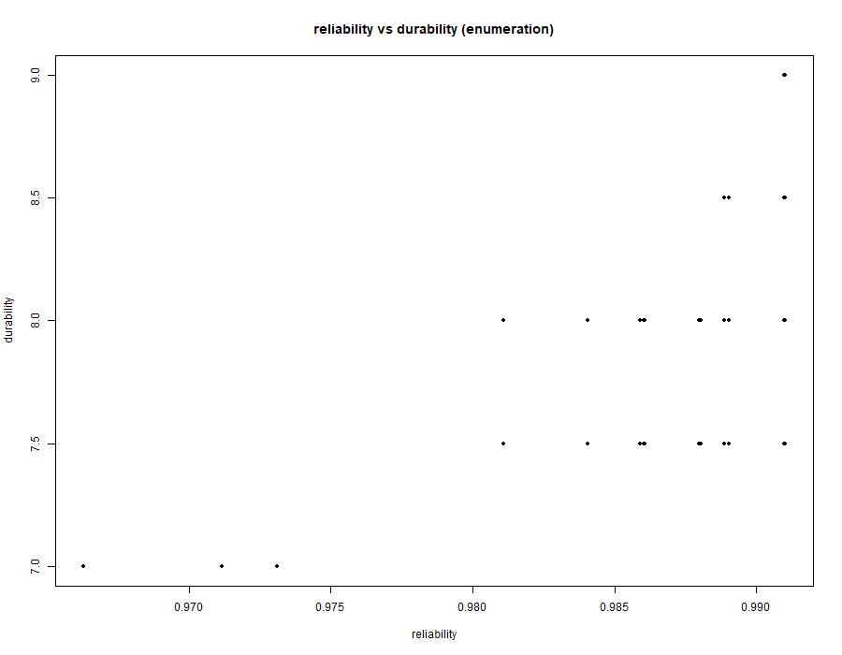

Figure 3.2: Reliability vs. Durability Tradespace

Certification Schedule vs. Reliability
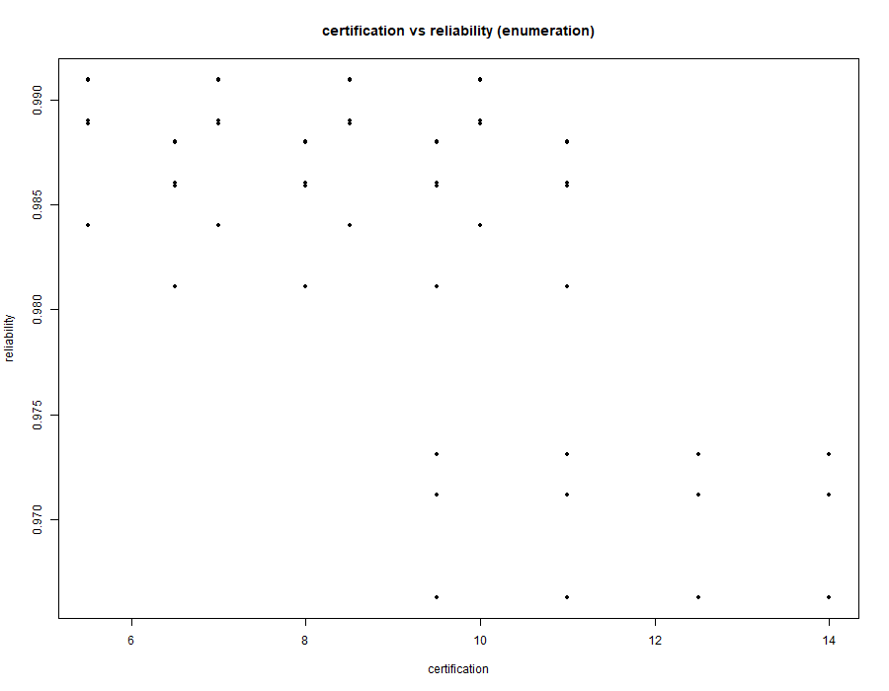

Figure 3.3: Certification Schedule vs. Reliability Tradespace

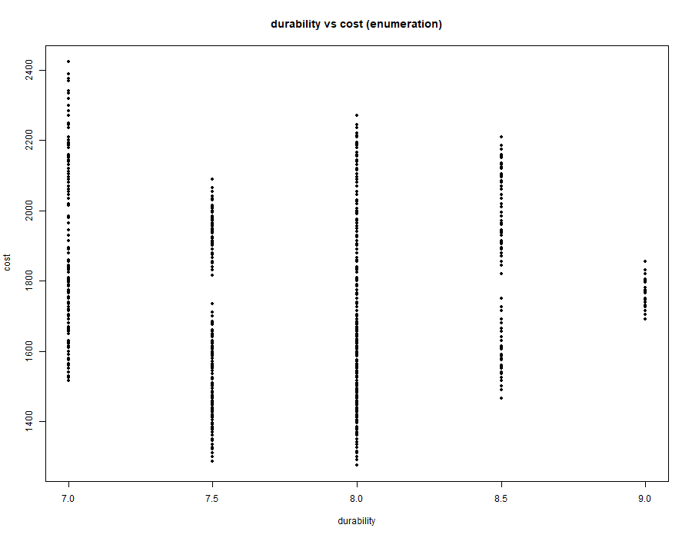
Durability vs. Cost

Figure 3.4: Durability vs.Cost Tradespace
Cost vs. Reliability

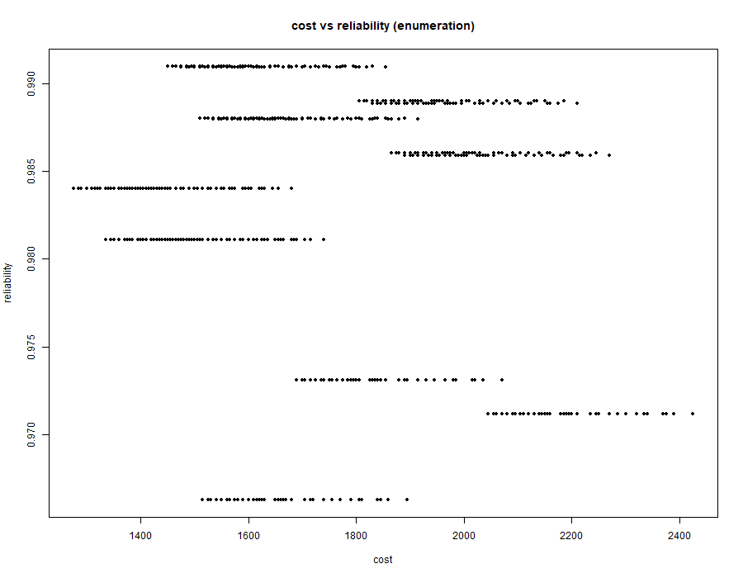
Figure 3.5 : Cost vs.Reliability Tradespace

Cost vs. Certification Schedule
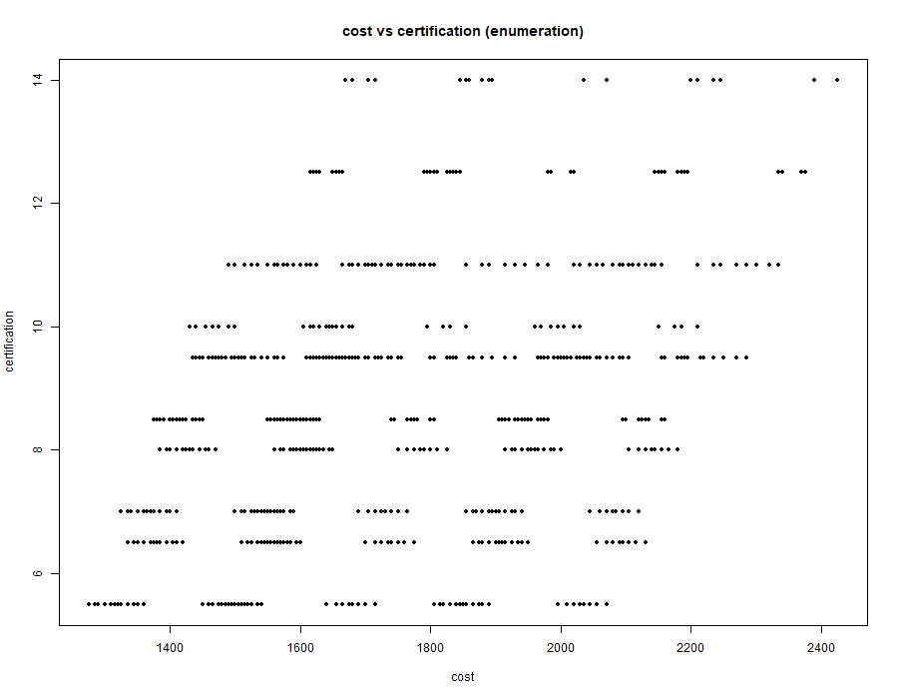

Figure 3.6 : Cost vs.Certification Schedule Tradespace

Each plot represents a projection of the full design space, allowing insight into dominant trade-offs between competing objectives.
It should be noted that the tradespace results are dependent on the assumed subsystem mappings and heuristic parameter values. A full uncertainty and sensitivity analysis is outside the scope of this stage but represents an important extension for future work.

3.4 Tradespace Analysis

3.4.1 Global Structure of the Feasible Tradespace
The tradespace analysis was conducted over the full constrained architecture space of 184,212 feasible aircraft configurations, generated from the eight architectural decisions D1–D8 and evaluated against the four primary metrics M1–M4: operating cost, propulsion reliability, system durability, and certification schedule. This section follows the same R/archr enumeration workflow described in the earlier architecture formulation, with the downstream analysis of sensitivity, connectivity, feature mining, and Pareto structure (Specking et al. ,2018). The exhaustive nature of the enumeration is important: no sampling approximation was used, so the results characterize the complete feasible design space rather than a subset.
At the objective-space level, the tradespace exhibits the expected multi-objective tension between low operating cost and short certification schedule on one hand, and high reliability and durability on the other. The plots show that architectures which are attractive on cost or schedule often sacrifice at least one of the safety-oriented metrics, while more robust architectures incur added complexity, integration burden, or component cost. The reference architectures were used as anchors for interpretation: RA1 provides a lower-bound complexity baseline, RA2 represents a current industry-standard configuration, and RA3 approximates a high-fault-tolerance upper bound. Together, these anchors frame the feasible space as a structured trade-off surface rather than a random cloud of points.

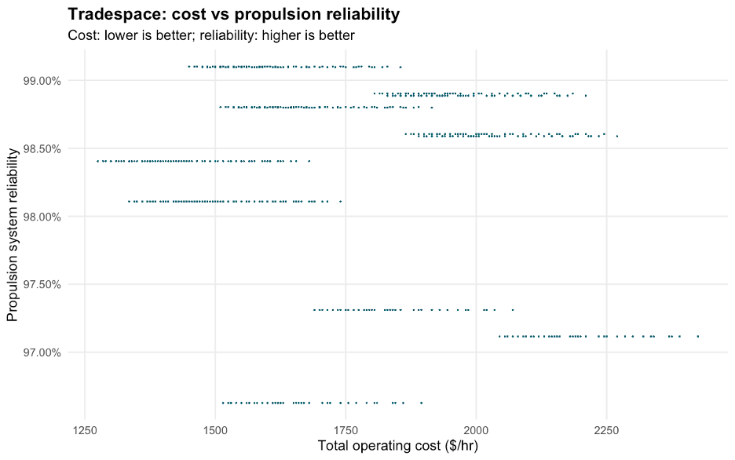
Figure 3.7 : Operating Cost vs Propulsion Reliability tradespace chart

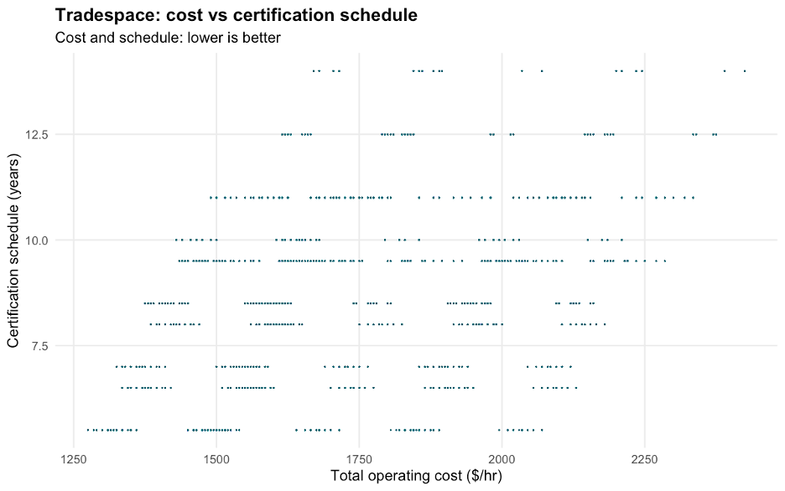

Figure 3.8 : Operating Cost vs Certification Schedule tradespace chart

A useful first-order observation is that the feasible space is not uniform. Instead, it contains recognizable regions in which particular architectural choices systematically dominate the objective values. The results explicitly note that there are visible tradeoff patterns between cost/schedule and reliability/durability, but also a balanced subset of architectures that remains feasible across several objectives simultaneously. This balanced region explains why multiple architectures appear on or near the Pareto front, rather than a single isolated optimum. In other words, the tradespace is highly structured, and the structure is driven by a small number of decision variables with disproportionate influence.
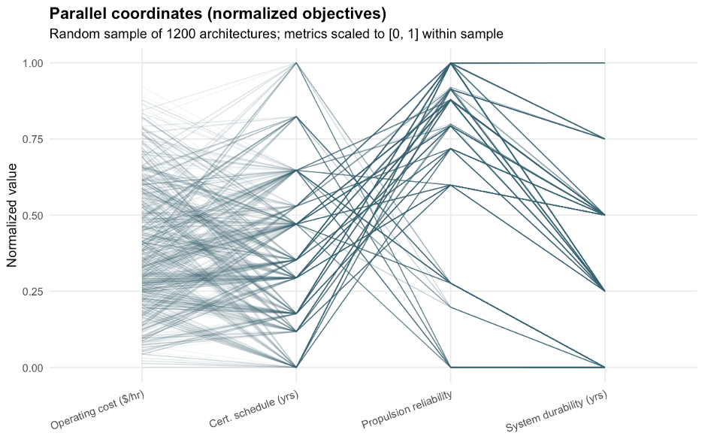

Figure 3.9 : Tradespace Scatterplots and Histograms

3.4.2 Pareto Structure and Near-Optimal Regions
The Pareto analysis shows that the dominant architectures share a common structural pattern. In the first nondominated layer, the architectures are strongly concentrated around D1 = 0, which corresponds to the Series Hybrid propulsion topology, and the same layer consistently excludes nose and tail motor placements while favoring D8 = 1, the ballistic parachute option. The feature-mining results further indicate that many rank-one designs use three partitions in D7, although a smaller subset achieves comparable performance with two partitions. This pattern is consistent with the earlier conclusion that the best architectures are those that combine a low-cost, lower-complexity propulsion baseline with selective safety augmentation rather than those that attempt to maximize every subsystem simultaneously.
The Pareto-front discussion also highlights an important modeling limitation: many distinct D7 configurations collapse to identical or nearly identical values of cost, schedule, reliability, and durability. As a result, the front contains equivalence classes rather than a unique best architecture. This means the frontier is informative for identifying the high-value region of the tradespace, but not always sufficient for distinguishing among architectures that are effectively equivalent under the current metric model.
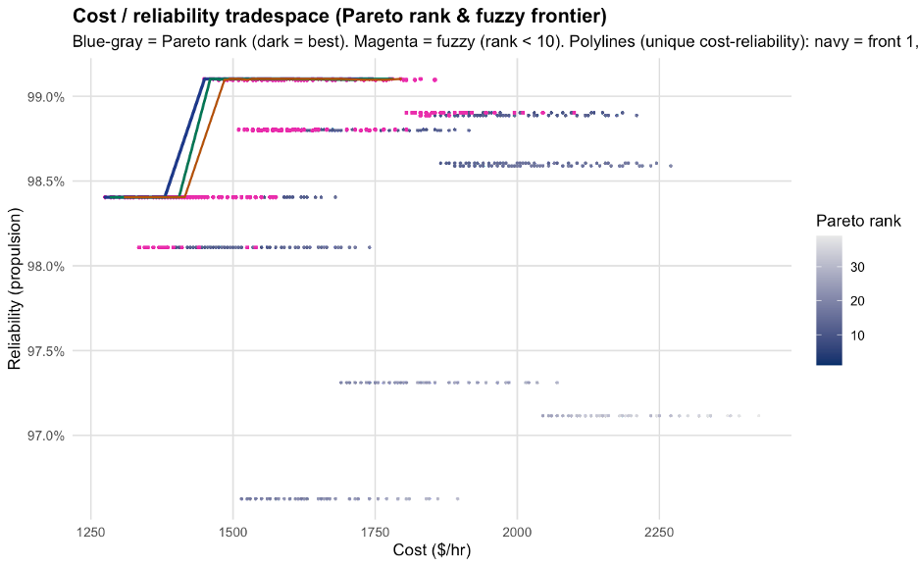

Figure 3.10 : Fuzzy Pareto frontier highlighted on the cost-reliability plot

3.4.3 Sensitivity and Connectivity of the Architectural Decisions
The sensitivity/connectivity analysis provides the clearest quantitative map of how the architectural decisions drive the metrics (Ross & Hastings, 2006). Sensitivity captures the magnitude of the isolated main effect of a decision, while connectivity captures the degree of interaction coupling with the rest of the architecture. Interpreted together, these two quantities identify which decisions behave as global architectural hubs and which behave as more modular “levers.”
For operating cost, D3 (Number of Electric Motors) is the dominant driver, with sensitivity 662.3 and connectivity 2474.9. The motor-placement decisions in D4, particularly D4_1 through D4_4 and D4_6, also exhibit very large sensitivity values of roughly 319.8 and connectivity above 1000. This indicates that cost is not governed by a simple linear preference ordering; rather, it behaves as a highly coupled function of propulsion count and spatial distribution. Adding motors is therefore expensive not only because it increases hardware quantity, but also because it introduces cascading integration and placement effects that compound across the architecture.
For the certification schedule, the leading drivers are D1 (Propulsion Topology) and D5 (FCC Redundancy), with sensitivities of 5.56 and 4.61 years, respectively. D6 (Avionics Integration) has a large sensitivity of 3.0 years but near-zero connectivity, which means it acts as a strong but relatively independent schedule penalty. D7 sub-variables, especially D7_5 and D7_6, exhibit high connectivity despite lower main effects, showing that subsystem partitioning can complicate certification primarily through interaction with redundant hardware rather than through a single direct schedule penalty. This result is important because it separates “expensive by itself” decisions from “expensive because they create coupling.”
For propulsion reliability, the most important direct drivers are D1 with sensitivity 0.025 and D4_6 with sensitivity 0.0128. The connectivity analysis shows that D1 and D3 are the most interconnected decisions, which is consistent with the fact that reliability is governed by the series/parallel structure of the fault tree and by the number of redundant propulsion pathways. In practical terms, the propulsion topology determines the reliability ceiling of the entire system, while motor count and placement determine how much redundancy can actually be realized in the physical architecture.
For system durability, D1 again appears as a leading driver with sensitivity 1.56, followed by D2 (Battery Chemistry) with sensitivity 0.89. D2 and D3 also display elevated connectivity, with values of 3.85 and 3.07. This is a strong indication that durability is governed by the interaction between battery chemistry degradation and the mechanical and thermal demands imposed by the propulsion configuration. The result is physically intuitive: battery selection is not merely a local storage decision, but a lifecycle choice that interacts with propulsion loading, thermal stress, and replacement interval.

3.4.4 Simmon’s 4-Quadrant Interpretation of the Tradespace
The Simmon’s 4-quadrant chart converts the sensitivity/connectivity results into an actionable systems-engineering heuristic. The upper-right quadrant contains the architectural hubs, most clearly D1 and D3. These are the decisions that should be explored early and then frozen, because they create the largest shifts in system performance while also triggering the broadest downstream rework. The choice between series, parallel, and turboelectric topologies physically constrains propulsion sizing, placement, and power routing, while motor count affects mass fraction, wing loading, and fault-tree redundancy all at once.
The upper-left quadrant contains the independent levers, most notably D6, D2, and D4_6 depending on the metric under examination. These decisions can change performance substantially without forcing a redesign of the entire aircraft. For example, the avionics integration choice can impose a large schedule penalty without changing the propulsion topology, and battery chemistry can materially affect cost without propagating mechanical redesign throughout the airframe. This makes them suitable for later-stage tuning once the architecture has been stabilized around the hub decisions.
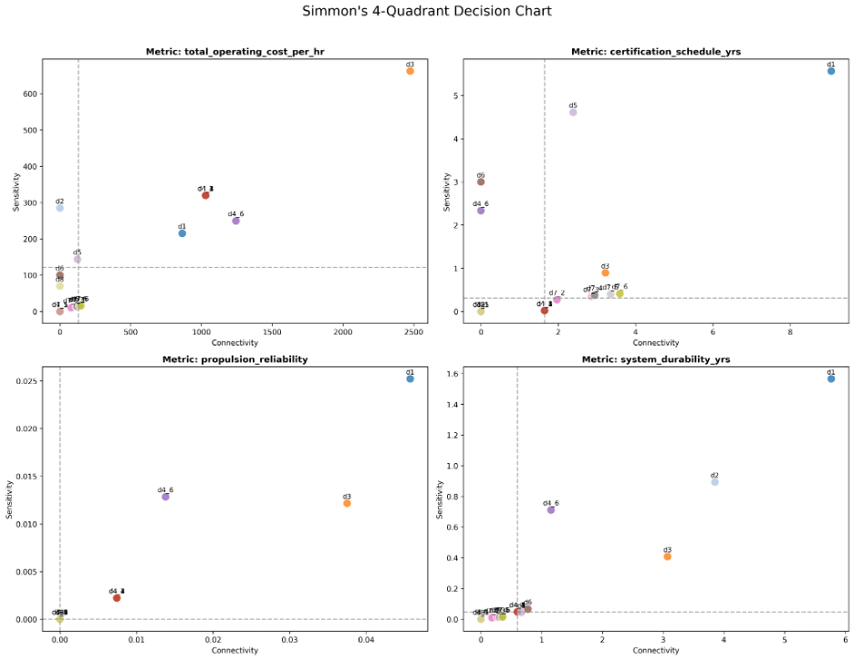

Figure 3.11 : Simmon’s 4-Quadrant Decision Chart
The lower quadrants contain secondary drivers and constraint-like decisions. These are less influential in isolation but still matter because they either reinforce the dominant hubs or enforce interface discipline. The practical implication is that the program should front-load attention on D1, D3, and D5, while keeping D2, D6, and selected D7 decisions available for later optimization. This sequencing reduces the risk of late-stage architectural churn and supports a more disciplined conceptual-design process.

3.4.5 Feature Mining and Architectural Design Rules
The association-rule analysis on the fuzzy Pareto region provides the most compact summary of the design rules implied by the tradespace (Bang & Selva, 2016). Using the fuzzy Pareto front as the good region G, the analysis shows that the Series Hybrid topology D1 = 0 is a near-universal invariant. It appears in only 39.22% of the full tradespace, yet it has reverse confidence of 1.0 with respect to the good region, meaning every architecture in G uses the Series Hybrid topology. Its lift of 2.55 confirms that it is not merely common, but strongly enriched among the best solutions.
The second major rule is that good architectures avoid nose and tail motors. The combined feature D4_5 = 0 and D4_6 = 0 has reverse confidence 0.8837, showing that the overwhelming majority of high-performing architectures keep propulsion units on the wing rather than at the fuselage ends. This suggests that the fuselage-mounted motor locations impose a structural, integration, or reliability penalty that outweighs any local performance benefit. The feature-mining result therefore aligns with the sensitivity/connectivity analysis: the propulsion placement decisions are not interchangeable, and the end locations are systematically disfavored.
The strongest synergistic rule in the study is D1 = 0 combined with D8 = 1. This feature has lift 3.3372 and forward confidence 0.3851, making it the single most informative combined feature in the analysis. The interpretation is that the Series Hybrid baseline creates a cost and reliability foundation that allows the independent safety boost of the CAPS parachute to move the architecture decisively into the non-dominated region. Put differently, the parachute is most valuable when it augments an already efficient and stable propulsion baseline.
The feature-mining results also identify an anti-feature: the single-motor architecture D3 = 0 has lift 0.6705, meaning it is less likely than random selection to appear in the good region. This is exactly what one would expect from a propulsion fault-tree perspective, because a single propulsion pathway creates a single point of failure that is difficult to offset with downstream design choices. It is not simply that redundancy is useful, but that propulsion redundancy is structurally necessary for Pareto competitiveness.

3.4.6 Cross-Check Against the Genetic Algorithm Results
The multiobjective genetic algorithm provides an independent check on the exhaustive tradespace results, but it does not replace them (Deb et al., 2002). The final generation produced only one unique nondominated architecture, indicating strong convergence and limited diversity in the population. The GA-produced front is described as a subset of the exhaustive Pareto set rather than a complete recovery of it, and the reported performance suggests that the GA identified competitive solutions with reliability above 0.98 and cost near 1275 $/hr, but with reduced spread across the objective space.
This GA outcome is consistent with the broader tradespace interpretation. The optimizer converges toward the same key design regions identified by the exhaustive analysis, especially the repeated appearance of D1, D2, D5, D6, and D8 in the better solutions, but it also exhibits premature convergence because several objectives vary only weakly across the remaining population. As a result, the GA is useful as a confirmation tool, but the exhaustive enumeration remains the primary source of truth for structural tradespace behavior.

3.4.7 Summary of Driving Decisions
Taken together, the tradespace analysis shows that the architecture is organized around a small set of dominant decisions rather than a diffuse collection of equally important choices. D1 (Propulsion Topology) and D3 (Number of Electric Motors) are the core architectural hubs; D5 (FCC Redundancy) and D6 (Avionics Integration) strongly influence certification behavior; D2 (Battery Chemistry) primarily governs lifecycle durability and cost; D4 determines whether propulsion placement reinforces or undermines the chosen topology; D7 introduces coupling through maintainability and partitioning; and D8 functions as a strong but relatively independent safety lever. The most successful architectures are therefore not those that maximize every subsystem in isolation, but those that align a Series Hybrid propulsion baseline with wing-centered redundancy and selective safety augmentation. (Palaia & Abu Salem, 2023)

3.5 Optimization and Selection

3.5.1. Optimization Setup (Multi-Objective Genetic Algorithm)
The architectural selection problem was formulated as a constrained multi-objective optimization problem and solved using a Multi-Objective Genetic Algorithm (MOGA), consistent with the NSGA-II framework applied in HW#5. The objective of the optimizer is to approximate the Pareto-optimal frontier of a discrete tradespace consisting of 184,212 feasible aircraft architectures, while simultaneously balancing four competing system-level objectives: operating cost, certification schedule, propulsion system reliability, and system durability.

Representation (Encoding)
Each architecture is initially defined as a mixed-integer decision vector spanning design variables D1–D8, where decisions include binary, categorical, and partition-based variables representing propulsion, energy storage, avionics architecture, redundancy allocation, and subsystem decomposition.
To interface with the genetic algorithm implementation, this integer-based representation is further transformed into a fixed-length binary chromosome using an int2bit encoding function. In this process, the full decision vector (18 discrete decision elements) is mapped into a binary string of length 26, ensuring compatibility with the binary genetic algorithm structure while preserving one-to-one correspondence with the original architectural variables.
This binary encoding enables the GA to perform crossover and mutation operations at the bit level, while a decoding step is applied during evaluation to reconstruct the original integer decision vector before computing system-level performance metrics. This ensures that genetic operators operate in a standardized search space while maintaining interpretability at the system architecture level.

Genetic algorithm configurations
The algorithm operates with a fixed population size of 200 individuals and is executed for 200 generations, providing a balance between solution quality and computational cost. A binary tournament selection strategy is used to preferentially select non-dominated and high-crowding-distance individuals, ensuring convergence toward the Pareto front while maintaining diversity.
A uniform crossover operator is applied to recombine parental solutions at the bit level, enabling structured exchange of architectural features across designs. This is complemented by a low-probability mutation operator, which introduces stochastic variation to prevent premature convergence and maintain exploration of underrepresented regions of the design space.
NSGA-II’s non-dominated sorting mechanism is used to classify solutions into Pareto fronts, while crowding distance sorting ensures diversity preservation within each front.

Population Initialization
The initial population is generated using uniform random sampling over the feasible design space. This ensures broad coverage of propulsion, electrical, and avionics configurations while maintaining diversity across early-generation solutions.

Mutation Operator
A low-probability, type-aware mutation strategy is used. Binary variables (e.g., CAPS installation) are flipped probabilistically, while categorical variables (e.g., propulsion topology) are reassigned within feasible alternatives. This ensures controlled exploration without disrupting convergence stability.

Constraint Handling
Feasibility constraints arising from architectural dependencies (notably D3–D4 coupling and subsystem compatibility rules) are enforced through a repair-based mechanism within the GA loop. Infeasible offspring are corrected before evaluation. Additionally, heavily penalized fitness values are assigned to any residual infeasible architectures, ensuring exclusion from the Pareto set.

Termination Criteria
The algorithm is executed for a fixed number of generations. Convergence is assessed through stabilization of Pareto dominance structure and diminishing improvement in hypervolume across successive generations.

3.5.2. Pareto Front Structure and GA Convergence Behavior
The full factorial tradespace exhibits strong stratification in both operating cost and certification schedule, driven primarily by discrete architectural decisions such as propulsion topology (D1) and FCC redundancy (D5). As a result, the Pareto front is not smooth but forms a discrete, clustered surface reflecting the combinatorial nature of the design space.
The genetic algorithm (population = 200, generations = 200, crossover = 0.8, mutation = 0.1, elitism = 10) converges extremely rapidly, reaching its best solution within the first 10–20 iterations. After this initial phase, both the best and mean fitness values stabilize, indicating that the population collapses into a narrow region of the tradespace.
From iteration ~20 onwards, no further improvement in the best solution is observed (best fitness stabilizes at approximately -1450), while only oscillations in the mean fitness persist. This behavior indicates premature but stable convergence to a dominant feasible architecture rather than gradual Pareto-front exploration.
The resulting population contains multiple genotypically different architectures that map to identical objective values, suggesting redundancy in the encoding–fitness mapping and strong dominance of a small subset of high-impact decision variables (notably D1, D3, D5, and D7). Once these variables stabilize, remaining decisions only produce equivalent or near-equivalent designs without improving Pareto dominance.
Overall, the GA behaves as a fast-converging search that quickly identifies a flat region of the Pareto surface, after which exploration becomes ineffective due to limited mutation-driven diversity and strong constraint-driven feasibility pressure.

3.5.3. Selected Pareto-Optimal Architectures
Two representative architectures are selected from the Pareto frontier. These solutions are not globally optimal in any single objective but are non-dominated in the multi-objective sense and represent distinct engineering tradeoffs.

Architecture A: Balanced Efficiency–Certification Tradeoff Design
Decision vector:
0,1,1,0,0,1,1,0,0,0,0,0,0,1,0,0,0,1
Performance metrics:
- Operating Cost: 1450 $/hr
- Certification Schedule: 5.5 years
- Propulsion Reliability: 99.10%
- System Durability: 8 years
This architecture lies in the central region of the Pareto front and represents a balanced design configuration. It avoids excessive propulsion distribution complexity while maintaining high system-level redundancy in avionics and control systems.
Key characteristics:
- Moderate propulsion complexity, avoiding excessive certification penalties
- Efficient certification pathway due to reduced sequential dependencies
- High reliability achieved through balanced redundancy allocation
This architecture is attractive because it achieves near-frontier reliability without incurring disproportionate certification overhead associated with highly distributed propulsion systems.

Architecture B: High-Reliability Robust Design
Decision vector:
0,1,1,1,1,0,0,0,0,0,0,0,0,1,1,1,0,1
Performance metrics:
- Operating Cost: 1450 $/hr
- Certification Schedule: 5.5 years
- Propulsion Reliability: ~99.10%
- System Durability: 8 years
Although aggregate performance metrics are similar to Architecture A, this configuration differs significantly in internal redundancy allocation. Redundancy is concentrated within propulsion-adjacent and safety-critical subsystems rather than being distributed uniformly.
Key characteristics:
- Increased redundancy concentration in propulsion and control pathways
- Stronger fault tolerance at subsystem level
- Maintains certification efficiency without increasing schedule burden
This architecture is more suitable for high-risk operational environments where fault tolerance is prioritized over structural simplicity.

3.5.4. Rationale for Pareto Optimality
Both architectures are considered optimal because they lie on the non-dominated Pareto frontier. No alternative architecture in the explored tradespace can improve one objective without degrading at least one other objective.
They are optimal in the following multi-objective sense:
- High propulsion reliability (~99%) satisfies safety-critical constraints
- Moderate certification time (5.5 years) avoids excessive regulatory burden
- Controlled operating cost relative to high-complexity architectures
- Balanced structural redundancy without extreme propulsion distribution penalties
Importantly, both architectures reside in a stable region of the Pareto surface, where small perturbations in design variables do not result in large performance variations. This robustness is essential in practical systems engineering applications.

3.5.5. Model Interpretation and Limitations
While the genetic algorithm effectively identifies high-quality architectures, the results highlight structural limitations in the evaluation model. A significant number of distinct decision vectors map to nearly identical performance outcomes, indicating the presence of equivalence classes within the tradespace.
This behavior is primarily driven by:
- Linear additive cost modeling
- Deterministic certification schedule formulation
- Limited sensitivity of certain decisions (notably D7)
- Simplified independence assumptions in reliability aggregation
As a result, interaction effects between subsystems are underrepresented, particularly in integration-driven cost and certification dynamics.
Future model improvements could include:
- Stochastic modeling of certification delays
- Nonlinear coupling between propulsion and avionics integration
- Enhanced sensitivity modeling for partitioning decisions (D7)
- Explicit interaction terms for subsystem integration complexity

3.5.6. Summary
The multi-objective genetic algorithm successfully approximates the Pareto frontier of the aircraft architecture tradespace and identifies a structured set of high-performing system configurations.
The results demonstrate that optimal architectures are not extreme solutions but rather balanced configurations that trade moderate complexity for stability in certification, reliability, and durability. Furthermore, the optimization reveals that system performance is primarily governed by a small subset of high-impact architectural decisions, while the remaining variables act as secondary refinements within a constrained Pareto region.
Overall, the study confirms that meaningful architectural optimization in this system occurs within a structured and highly constrained subset of the full combinatorial design space.

4. Architecture Description
The selected architecture- Architecture A from Tradspace enumeration (Balanced Efficiency–Certification Tradeoff Design) was identified through the MOGA/NSGA-II optimization of a 184,212-point tradespace encoded by eight decision variables (D1–D8) in a 26-bit binary chromosome. It is a non-dominated Pareto-optimal solution balancing four competing objectives: operating cost, certification schedule, propulsion reliability, and system durability.

4.1 Selected Architecture Encoding and Rationale
Decision vector: [ 0, 1, 1, 0, 0, 1, 1, 0, 0, 0, 0, 0, 0, 1, 0, 0, 0, 1 ]
D | Decision | Selected | Rationale
D1 | Propulsion topology | Parallel Hybrid | Both thermal engine and electric motors drive the propeller via gearbox, enabling simultaneous or independent operation. Avoids excessive propulsion distribution complexity while maintaining high system-level redundancy.
D2 | Battery chemistry | Li-Ion (high energy density) | Supports peak power demands of the parallel hybrid configuration. Mature chemistry with established certification precedent; contributes to the 8-year durability target.
D3 | Electric motors | 2+ distributed | Distributed motors provide propulsive redundancy at moderate complexity — achieving near-frontier reliability without incurring disproportionate certification overhead.
D4 | Motor position | Wing-mounted | Wing placement provides structural integration with the airframe and maximizes propulsive efficiency in the parallel hybrid configuration.
D5 | FCC redundancy | Dual-lane FCC | Moderate redundancy; achieves near-frontier reliability (99.10%) while keeping the certification schedule at 5.5 years through reduced sequential dependencies.
D6 | Avionics | Integrated Modular (IMA) | Consolidates F4.1–F4.4 onto shared hardware, reducing LRU count and simplifying integration relative to a fully federated suite.
D7 | LRU decomposition | 2 packages — F6 isolated | F6 (Health Management) isolated in its own LRU for prognostic independence. Minimizes replacement cost and maintenance complexity.
D8 | CAPS | Installed | Provides last-resort system-level safety margin. Integrates with F3.3 (Trigger Emergency Recovery) and F5.3 (Passenger Restraint & Egress).

Table 4.1: Architecture A decision vector.

4.2 System Concept and Concept of Operations
The RUGA aircraft is an 8–10-seat next-generation general aviation aircraft with a parallel hybrid-electric propulsion system. The thermal engine provides primary thrust; electric motors provide redundancy and efficiency; the gearbox combines both outputs mechanically. Five Level-1 subsystems form the physical architecture: Airframe, Propulsion System, Electrical & Energy System, Flight & Control System, and Safety & Support System.

Primary use case (Figure 4.1): Passengers are transported safely to their destination. Fuel enables F1 (Generate & Manage Propulsion), which produces thrust for F2 (Control Flight Path). The flight plan is processed by F4 (Manage Avionics & Communications) and monitored by F3 (Monitor & Ensure Safety). In parallel, F5 (Support Cabin & Payload) and F6 (Enable Maintenance & Health Management) maintain cabin and system conditions throughout. All six functions collectively enable controlled flight.
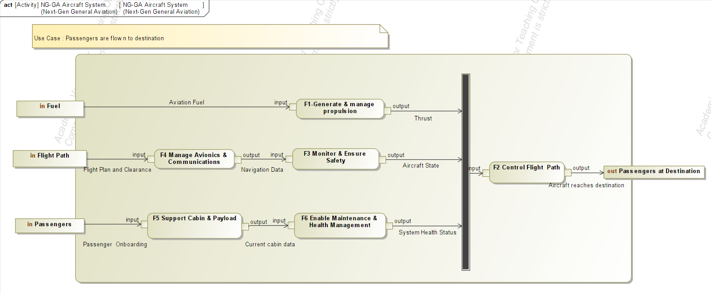

Figure 4.1 : Activity Diagram - Primary Use Case
Operational lifecycle state machine (Figure 4.2): The aircraft begins at Idle, entering either Pre-Flight checks or Maintenance. Once pre-flight clears, it proceeds Taxi → Takeoff → Climbing → Cruising. Nearing the destination it may enter Loiter (ATC hold) before Approaching → Landing, then returns to Idle. At any flight phase, a system fault triggers the Emergency state, routing to either an emergency landing or ground resolution.
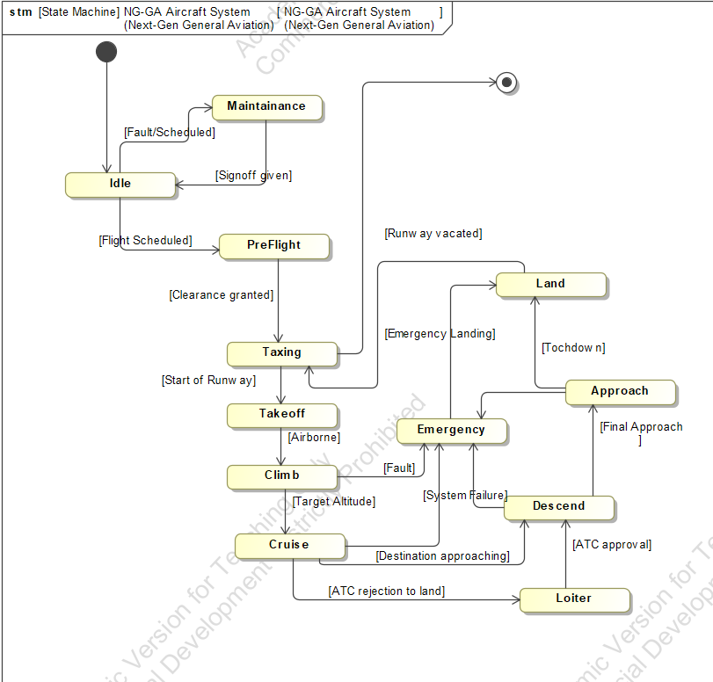

Figure 4.2 : State Diagram

4.3 Functional Architecture
The system is decomposed into six Level-1 primary functions, each further broken down into Level-2 sub-functions (22 total). The table below lists the primary functions and their system-level goals.

F-ID | Function | Description | Goals
F1 | Generate & Manage Propulsion | Produce and regulate thrust via the hybrid-electric powertrain (turbine/piston generator + battery + electric motors). Manage energy flow, redundancy switching, and fuel burn. | G1, G6, G9, G19
F2 | Control Flight Path | Translate pilot inputs and autopilot commands into control surface deflections and flight management actions. Enforce flight envelope limits. | G3, G13, G17, G18
F3 | Monitor & Ensure Safety | Continuously monitor all critical systems, detect faults, trigger redundant pathways, and provide crew/passenger emergency protection (ballistic parachute, automated recovery). | G1, G2, G4, G14, G18
F4 | Manage Avionics & Communications | Process navigation, communication, and surveillance data. Display situational awareness to the crew and transmit telemetry to ATC and ground systems. | G2, G13, G17, G20
F5 | Support Cabin & Payload | Maintain cabin environmental conditions (pressure, temperature, noise), manage passenger comfort, and accommodate mission-specific payload modules. | G11, G16, G19
F6 | Enable Maintenance & Health Management | Collect health/usage monitoring data from all subsystems, support diagnostics and prognostics, generate maintenance action recommendations, and enable modular replacement. | G4, G7, G8, G20

Table 4.2: Level-1 primary functions.
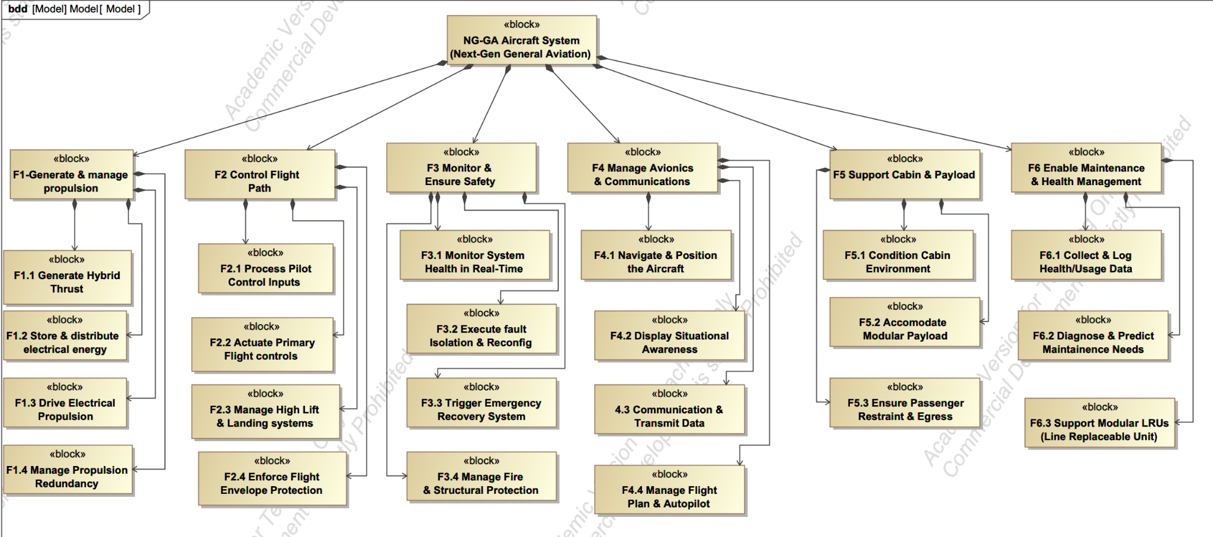

Figure 4.3: Sysml Bdd & hierarchical decomposition of functions

4.4 Physical Architecture
The physical architecture comprises five Level-1 subsystems and 19 Level-2 components, structured around the parallel hybrid-electric configuration.

4.4.1 Block hierarchy
Block | Lvl | Name | Description
B1 | 1 | Airframe | Structural body of the aircraft: fuselage, wings, tail, landing gear. Provides support for all subsystems.
B2 | 1 | Propulsion System | Provides thrust using parallel hybrid configuration. Traditional engine provides main power; electric motors provide redundancy and efficiency; gearbox combines them mechanically.
B3 | 1 | Electrical & Energy System | Stores and distributes electrical energy to all subsystems. Supports hybrid propulsion and powers electronics.
B4 | 1 | Flight & Control System | Interprets pilot input, processes sensor data, moves control surfaces.
B5 | 1 | Safety & Support System | Monitors system health, detects failures or fires, provides backup power for critical operations.
B2.1 | 2 | Thermal Engine | Traditional engine providing main thrust for the aircraft.
B2.2 | 2 | Electric Motors | Provides supplementary or redundant thrust; used in hybrid mode.
B2.3 | 2 | Gearbox | Combines thermal engine and electric motor output to propeller efficiently.
B2.4 | 2 | Propeller | Converts engine/motor rotation into thrust; essential for hybrid operation.
B3.1 | 2 | Battery Packs | Redundant energy storage for hybrid operation and electronics.
B3.2 | 2 | Power Distribution Unit | Delivers electrical power to other subsystems safely.
B3.3 | 2 | Power Electronics | Manages charging, discharging, and power flow between batteries, motors, and computers.
B4.1 | 2 | Flight Control Computers | Processes pilot commands and sensor data; decides how to move actuators.
B4.2 | 2 | Actuators | Move ailerons, elevators, rudder, and flaps to control aircraft.
B4.3 | 2 | Control Surfaces | Moves to control the airframe orientation of the aircraft.
B5.1 | 2 | Health Monitoring System | Continuously monitors propulsion, electrical, and flight systems for faults.
B5.2 | 2 | Environmental Control System | Maintains cabin pressure and temperature.
B5.3 | 2 | Emergency Power Unit | Provides and stores backup power for emergency scenarios.
B5.4 | 2 | Avionics | Navigation, communication, and monitoring systems.

Table 4.3: Physical block hierarchy.

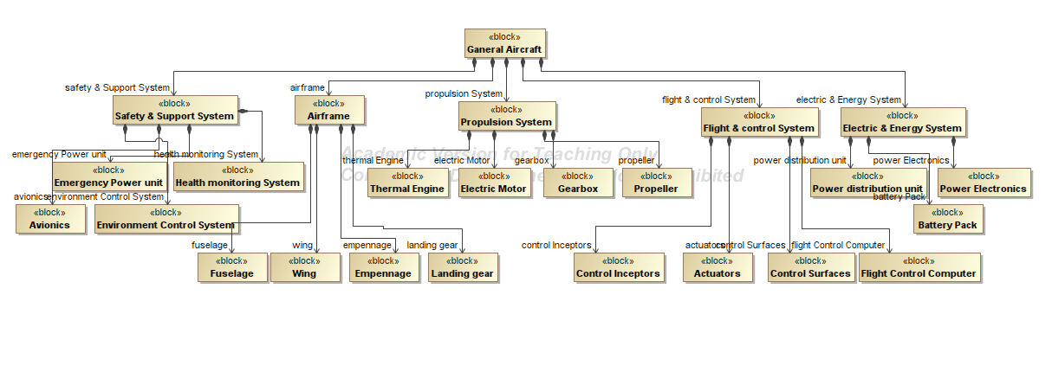Figure 4.4: Physical Architecture : Block Definition Diagram

4.4.2 Level-1 interfaces
Physical interfaces:
Sender | Receiver | Interface | Port type
Propulsion System | Airframe | Torque transmission | Flow Port (Mechanical)
Propulsion System | Electrical & Energy System | Charging / electrical feedback | Flow Port (Electrical)
Electrical & Energy System | Flight & Control System | Power supply | Flow Port (Electrical)
Electrical & Energy System | Safety & Support System | Power supply | Flow Port (Electrical)

Table 4.4: Level-1 physical and informational interfaces.
Informational interfaces:
Sender | Receiver | Interface | Port type
Flight & Control System | Propulsion System | Control signals | Proxy Port / Full Port
Flight & Control System | Safety & Support System | Status / requests | Standard Port
Propulsion System | Flight & Control System | Sensor feedback | Flow Port / Signal
Airframe | Flight & Control System | Sensor feedback | Flow Port / Signal
Safety & Support System | Flight & Control System | Fault alerts | Standard Port
Safety & Support System | Propulsion System | Fault alerts | Standard Port

Table 4.5: Level-1 physical and informational interfaces.
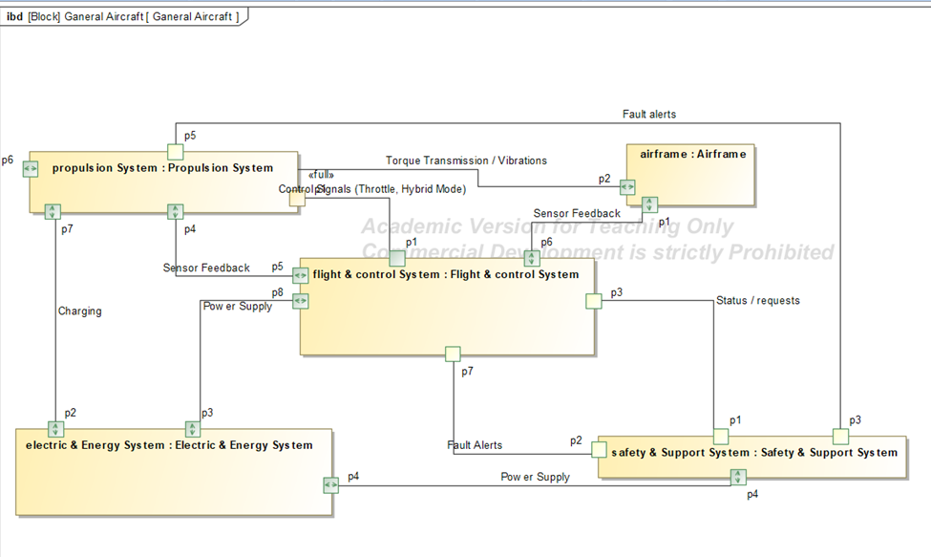

Figure 4.5: Internal Block Diagram

4.4.3 Level-2 DSM connectivity observations
• High intra-subsystem density: Airframe and Propulsion exhibit dense mechanical (red) couplings, Thermal Engine, Electric Motors, and Gearbox physically integrate to transfer torque to the Propeller.
• Airframe as physical hub: The fuselage shows widespread mechanical connections (red) across almost all other subsystems, physically supporting wings, empennage, landing gear, thermal engine, and gearbox.
• Power Distribution Unit as electrical bus: Creates an extensive band of electrical connections (blue) across the matrix, supplying Electric Motors, Flight Control Computers, Actuators, and Safety/Support systems.
• FCC and Health Monitoring System as informational hubs: Their connectivity (green) spans the full matrix pulling sensor data from propulsion/airframe elements and pushing control signals to actuators and avionics.
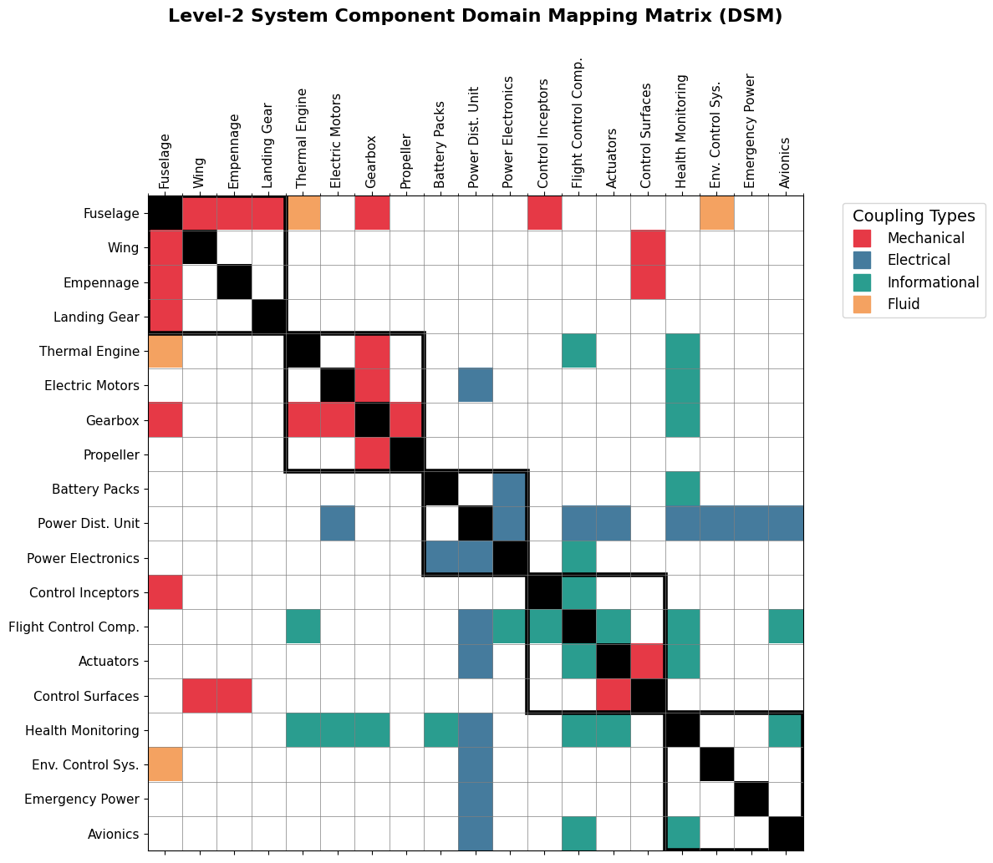

Figure 4.6: Level-2 Design Structure Matrix.

4.5 Allocation Architecture

4.5.1 Level-1 function-to-subsystem allocation
The six primary functions are allocated to the five physical subsystems as follows:
- F1 (Generate & Manage Propulsion): shared between Propulsion System (F1.1 thrust generation, F1.3 motor drive) and Electrical & Energy System (F1.2 energy storage and distribution).
- F2 (Control Flight Path): allocated to Flight & Control System.
- F3 (Monitor & Ensure Safety), F4 (Manage Avionics & Communications), F6 (Enable Maintenance & Health Management): all allocated to Safety & Support System.
- F5 (Support Cabin & Payload F5.2 and F5.3): allocated to the Airframe, which acts as the physical structure responsible for accommodating passengers and receiving aerodynamic and propulsive forces.
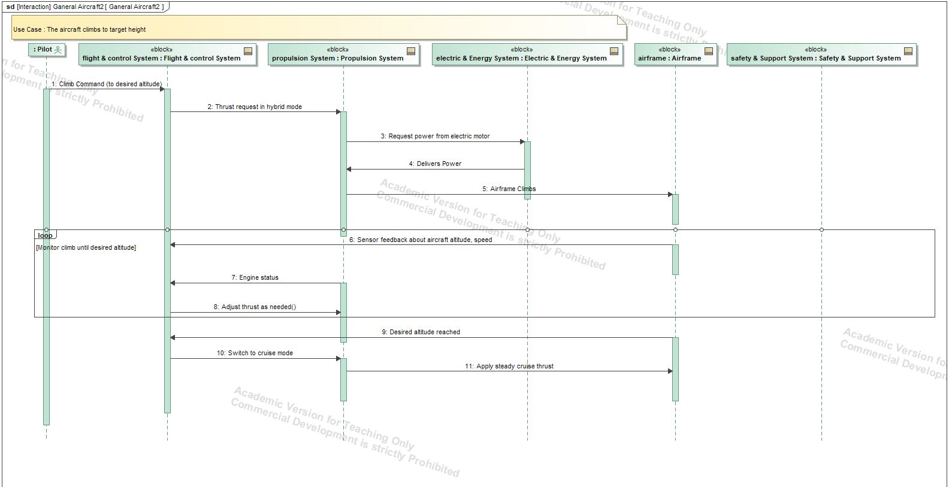

Figure 4.7: Level-1 Allocated Architecture Activity Diagram with swimlanes.

4.5.2 Level-2 sub-function to component allocation key mappings
- Functional clustering (many-to-one): The Health Monitoring System appears as a dense vertical block; it is the primary hardware host for almost all safety monitoring (F3.1–F3.4) and health management (F6.1–F6.3) functions.
- Distributed physical execution (one-to-many): F1.1 (Generate Hybrid Thrust) requires coordinated operation of Thermal Engine + Electric Motors + Gearbox + Propeller. Similarly, F2.2 (Actuate Primary Flight Controls) relies on Actuators + Control Surfaces + Wings + Empennage functioning together.
- Integrated control logic: F4.4 (Manage Flight Plan & Autopilot) splits between Avionics (providing navigation data) and Flight Control Computers (executing control laws).
- Sparse structural columns: Passive components carry targeted allocations — Fuselage to F5.2/F5.3 (payload and passenger accommodation), Landing Gear to F2.3, Wings/Empennage to F2.2.
- Integrated bridge components: Power Electronics has scattered mappings across Energy and Propulsion functional groups, confirming its role as a bridge between power storage and thrust generation.

4.6 Architecture Summary
Architecture A Parallel Hybrid, Li-Ion battery, distributed electric motors, dual-lane FCC, IMA avionics, 2-LRU partition with F6 isolated, CAPS installed represents the balanced efficiency–certification tradeoff on the Pareto frontier. It achieves near-frontier propulsion reliability (99.10%) through moderate propulsion complexity, avoids disproportionate certification overhead through reduced sequential dependencies, and maintains an 8-year system durability through balanced redundancy allocation. Optimal architectures in this tradespace are not extreme solutions but balanced configurations that trade moderate complexity for stability across certification, reliability, and durability simultaneously.
Metric | Value | Target | Status
Operating cost (M1) | $1,450 / hr | $250/hr (G10) | Within bound
Propulsion reliability (M2) | 99.10% | ≥99% (G1, G18) | Meets target
System durability (M3) | 8 years | G4 target | Meets target
Certification schedule (M4) | 5.5 years | FAA/EASA (G2, G13) | Balanced
Pareto status | Non-dominated (Architecture A) | MOGA optimization result | Confirmed

Table 4.6: Performance against system goals..

5. Conclusion
This project explored the conceptual architecture and tradespace of a next-generation hybrid-electric General Aviation (GA) aircraft family designed around a resilience-first systems engineering philosophy. Rather than optimizing only traditional aircraft performance metrics such as speed or payload, the study focused on improving survivability, operational reliability, fault tolerance, and lifecycle sustainability while remaining compatible with FAA Part 23 certification constraints. Through a combination of stakeholder analysis, functional decomposition, architectural enumeration, and tradespace exploration, the project demonstrated how early-stage systems engineering methods can be used to identify high-value architectural regions before detailed engineering design begins.
The stakeholder analysis established that Aircraft Owners, Passengers, Flight Schools, and Investors form the dominant economic and operational core of the value network, while the FAA functions as a critical regulatory gatekeeper despite receiving a lower quantitative stakeholder score. The analysis also showed that the system cannot succeed as an isolated technical product; instead, it depends on a coordinated ecosystem involving operators, insurers, maintainers, regulators, and infrastructure providers. The value-loop analysis reinforced this conclusion by identifying safety, sustainment, and capital-investment feedback loops as structurally critical to long-term viability.
The architectural formulation phase defined eight major architectural decisions (D1–D8) spanning propulsion topology, battery chemistry, propulsion redundancy, avionics integration, subsystem decomposition, and emergency recovery systems. Enumeration-level constraints captured the dependencies between propulsion topology, motor count, subsystem partitioning, and redundancy allocation, resulting in a constrained but highly expressive design space. Functional and operational architecture analysis further demonstrated how propulsion management, safety monitoring, flight control, avionics, and maintenance systems interact through shared control and information flows.
The tradespace analysis produced the most significant findings of the study. Sensitivity and connectivity analysis showed that D1 (Propulsion Topology) and D3 (Number of Electric Motors) behave as the dominant architectural hub decisions, exerting strong influence across cost, reliability, durability, and certification schedule simultaneously. D5 (FCC Redundancy) and D6 (Avionics Integration) emerged as major certification and integration drivers, while D2 (Battery Chemistry) strongly affected lifecycle durability and operating cost. Feature-mining analysis demonstrated that the highest-performing architectures consistently favored the Series Hybrid topology, avoided nose and tail motor placements, and frequently incorporated the CAPS ballistic parachute system as an independent survivability enhancement. In contrast, single-motor architectures were systematically underrepresented in the high-performing region of the tradespace, indicating that propulsion redundancy is structurally necessary for Pareto competitiveness.
Despite these insights, several important limitations remain. First, the analysis was conducted at the conceptual architecture level and therefore relied on simplified surrogate metric models rather than high-fidelity aerodynamic, thermal, structural, or certification simulations. Reliability, durability, and certification schedule were represented through semi-quantitative relationships and assumed mappings rather than detailed probabilistic engineering models. Second, the operating-cost model did not include full lifecycle economic effects such as manufacturing tooling cost, supply-chain volatility, infrastructure retrofitting, pilot retraining, or battery recycling logistics. Third, several architectural decisions, particularly D7 subsystem decomposition, produced equivalence classes in which many physically distinct architectures mapped to nearly identical metric values, reducing discrimination capability within the Pareto set. Finally, the tradespace assumed static stakeholder preferences and regulatory conditions, even though real-world aviation markets and certification standards evolve over time.
Future work should therefore focus on improving both model fidelity and architectural realism. Higher-fidelity physics-based models could be integrated to evaluate aerodynamic efficiency, propulsion thermal management, structural loads, and mission-level energy consumption more accurately. Additional architectural decisions could also be introduced, including wing configuration, thermal-management architecture, autonomous flight-assist capability, and energy-storage modularity. Probabilistic risk assessment methods such as Monte Carlo reliability simulation or fault-tree analysis could strengthen the safety evaluation framework, while dynamic stakeholder utility modeling could better capture changing market and regulatory conditions. Finally, future studies should incorporate uncertainty quantification and robust optimization methods to evaluate how architectures perform under uncertain technological maturity, certification delays, and future battery-development trajectories. These extensions would transform the present conceptual exploration into a more operationally realistic aircraft system design framework suitable for early-stage aerospace decision support.

6. References

Fraser, T., Aldrich, D. P., & Page-Tan, C. (2021). Bowling alone or distancing together? The role of social capital in excess death rates from COVID19. Social Science & Medicine, 284, 114241.

Deb, K., Pratap, A., Agarwal, S., & Meyarivan, T. (2002). A fast and elitist multiobjective genetic algorithm: NSGA-II. IEEE Transactions on Evolutionary Computation, 6(2), 182–197. https://doi.org/10.1109/4235.996017

Specking, E., Parnell, G., Pohl, E., & Buchanan, R. (2018). Early Design Space Exploration with Model-Based System Engineering and Set-Based Design. Systems, 6(4), 45. https://doi.org/10.3390/systems6040045

Bang, H., & Selva, D. (2016). iFEED: Interactive feature extraction for engineering design. In Proceedings of the ASME 2016 International Design Engineering Technical Conferences and Computers and Information in Engineering Conference: Vol. 7. 28th International Conference on Design Theory and Methodology (Article V007T06A037). ASME. https://doi.org/10.1115/DETC2016-60077

Palaia, G., & Abu Salem, K. (2023). Mission Performance Analysis of Hybrid-Electric Regional Aircraft. Aerospace, 10(3), 246. https://doi.org/10.3390/aerospace10030246

Ross, A., & Hastings, D. (2006). Assessing changeability in aerospace systems architecting and design using dynamic multi-attribute tradespace exploration. In Space 2006. American Institute of Aeronautics and Astronautics. https://doi.org/10.2514/6.2006-7255

Systems Architecture: Strategy and Product Development for Complex Systems, 1st edition
Published by Pearson (October 26, 2023) © 2024,Edward CrawleyBruce CameronDaniel Selva

PART 23—AIRWORTHINESS STANDARDS: NORMAL CATEGORY AIRPLANES https://www.ecfr.gov/current/title-14/part-23

X-57 Maxwell Overview https://www.nasa.gov/centers-and-facilities/armstrong/x-57-maxwell/

Cirrus Airframe Parachute System and Odds of a Fatal Accident in Cirrus Aircraft Crashes
Mustafa Alaziz, Adrienne Stolfi, Dean M Olson
PMID: 28539144 DOI: 10.3357/AMHP.4679.2017

Cessna 172 POH/specifications https://wayman.edu/files/Cessna-172N-POH.pdf

Appendix
Code Links:
All codes are present at : https://github.com/janhaviprof-bot/SystemsArchitecture/tree/main/Code

Enumeration | https://github.com/janhaviprof-bot/SystemsArchitecture/blob/main/Code/Enumeration.R
Evaluation | https://github.com/janhaviprof-bot/SystemsArchitecture/blob/main/Code/Evaluation.R
Genetic Algorithm | https://github.com/janhaviprof-bot/SystemsArchitecture/blob/main/Code/ga.R
DSM | https://github.com/janhaviprof-bot/SystemsArchitecture/tree/main/Code/Code-Kris
Simmon’s 4-Quadrant Decision Chart | https://github.com/janhaviprof-bot/SystemsArchitecture/tree/main/Code/Code-Kris

